An Oxford Mercer’s Life
by Soren Johnson

Prof. Paul Seaver
Prof. Carolyn Lougee
Honors Thesis
May 18, 1998
Table of Contents

Introduction 3
Chapter 1 – Historical Background 7
The Financial Strategies of Oxford Shopkeepers 8
Marriage 10
Diversification 15
A History of Oxford’s Mercers’ and Woolen Drapers’
Guild 24
Figure 1 55
Figure 2 56
Chapter 2 – Historical Simulation 57
Business 59
Investments 68
Society 72
Family 73
Chapter 3 – Simulation Instructions 77
Epilogue 94
Bibliography 95
Acknowledgements 101

Introduction
Exactly how well can we know history? More specifically, can we know enough about the past to accurately reconstruct historical environments? Naturally, no definitive answer exists for this general question. However, for certain scenarios, the outcomes are obvious. While simulating American demographics during the 1960’s is feasible task, tracing the spread of nationalism during the nineteenth century is not. Thus, our question is less a query than a challenge; how well, for example, can we simulate the Battle of Gettysburg or the American economy during the Great Depression? The answer depends on the strength of relevant primary sources as well as the generality of the situation. Could we, for example, use data from the Battle of Sharpsburg to help recreate Gettysburg, or was Gettysburg such a unique event that only data from that battle specifically is applicable? Moreover, we need to define exactly what is meant by a “simulation.” Would a recreation of Gettysburg trace the life of one randomly chosen soldier over a three day period? Would it calculate the losses of the Union and the Confederacy depending on mutable variables, such as what might have happened if Lee’s army had an extra 20,000 men? Thus, before beginning, the historian needs to determine what he or she wants to learn from the simulation and proceed accordingly.
This thesis is an exercise in exactly this type of historical recreation. I propose to simulate the life of an Oxford shopkeeper during the early modern period, specifically from 1660 until 1750. I intend to reconstruct as many aspects of their lives as possible from the existing data. Using shopkeeping records, I will simulate their economic affairs. From demographic data, I can recreate their social lives and the development of their families. By looking at investment trends during this period, I will determine how they used their excess capital when their businesses succeeded. Furthermore, since the mercers, grocers and drapers of Oxford were not qualitatively different from other provincial shopkeepers in England, I can use secondary sources which address their lives more generally to fill in gaps which my primary data leaves empty.
To help me construct my simulation, I will write a Macintosh application to let users experience the life of one specific Oxford mercer, whom I will name William Davis. Through this program, the user will be presented with the same choices that a shopkeeper during this period would have experienced: what type of merchandise to sell, what prices to set, how much credit to extend, what premiums to charge apprentices, etc. If my simulation is successful, William Davis’s success or failure will accurately reflect the historical results of these choices. Moreover, I endeavor to paint a broader picture and allow the simulation to chart the progression of William Davis’s family over a number of generations, as long as the shop remains within the family.
The sources for this project are varied. I tried to use primary data whenever possible and was able to find considerable information on marriage practices, financial investments, and guild history in the Oxford City and Oxfordshire County Archives. For more general data specific to the economic and social environment of Oxford and its surrounding area, I have relied heavily upon the Victoria County History for Oxfordshire. I am also deeply indebted to the work of Richard Grassby, Peter Earle, and Carole Shammas for data concerning the operation of businesses in England’s early modern period. For a rough guide to England’s overall economy, I have used Gregory King’s data from the 1690’s. The rest of my bibliography was used primarily for addressing specific aspects of the simulation, such as land prices, which were supplied by Clay’s article on the price of freehold land during this period.
This thesis is divided into three chapters. The first one contains three sections which examine, respectively, the financial investments, marriage practices and guild structure of Oxford’s shopkeepers. These sections concern themselves little with the actual simulation and are straight-forward historical research based on primary sources. In other words, these three parts could each stand as independent products of my work in Oxford’s archives. Because the act of simulation involves compromise, not all of this research is reflected in the final application. Therefore, I have written these sections independently so that I could give each topic a fair and thorough examination.
The second chapter reveals the process by which I turned my primary research and secondary knowledge in a viable computer simulation. The data model I used was often the result of much struggle and compromise as I tried to focus my reconstruction upon the common case, excluding unusual data I found which did not fit general trends. While these exceptions are what normally interest historians a great deal, they are counterproductive to the creation of an accurate simulation. For example, just because one provincial mercer bought land to farm himself is only marginally relevant to the simulation because the majority of shopkeepers bought land as an investment. Thus, even though a handful of exceptions exist, I prevent the user from farming his own land to reflect the fact that, in most cases, land was purchased by provincial distributors to diversify their assets and provide a secondary form of reliable income through rents. The important distinction to make here is that why shopkeepers chose to make the financial decisions they made is not as important to an accurate simulation as what choices they actually did make. In this way, I have built the computer simulation to encourage the user to follow the paths which most successful Oxford mercers, grocers and drapers followed, and in this second chapter, I will explain how I made the decisions to achieve such a goal.
In the final chapter, I provide a “user’s manual” for running the computer simulation. This application should run on any Macintosh with System 7.1 or later installed. I have included screen shots to help explain exactly how the application operates, but a basic knowledge of a graphical user interface such as Windows or Macintosh is assumed. The simulation is significantly complex enough that the user will need to spend some time to get familiar with its functionality, but I believe that the time invested will be rewarded by the program’s depth.
The final topic to address is whether this project can truly be considered “history.” In response to this question, I hope that the results speak for themselves. Although certain part of the simulation are more accurate than others due simply to what data is physically available, the sum of the application should be greater than its parts. In other words, operating the simulation is an experience not available in any book, article or paper on this topic. Only here is every significant aspect of a shopkeeper’s life collected and mixed together. The growth of William Davis’s family affects who will inherit the shop and how much profit the business needs to generate. The changing economy of Oxford affects guild membership which affects how quickly William Davis can climb through the political ranks of Oxford. Disasters, such as fires and plague, can destroy an otherwise successful shop. Extending too much trade credit will prevent the user from paying off his debts fast enough, but too little trade credit will slow business to an unprofitable rate. All these factors collide together in the simulation, and only the user who can balance all of them will succeed, a difficult task but no less difficult than trying to run a profitable shop in mid-seventeenth century Oxford. What is history? If the answer is a record of the past, then I present in this thesis a living, breathing record of the past.

I
Historical Background

The Financial Strategies of Oxford Shopkeepers
In seventeenth and eighteenth century England, business was believed to be a powerful opportunity for economic advancement. As was stated in the Commons of 1621, “the raysing of many good families from small beginnings and the recovery of many decayed houses of the Gentry” could be credited to profits from trade. Indeed, numerous merchants, usually based in London, did amass considerable fortunes. From 1660 to 1720, the estates of at least fifteen businessmen were worth more than £100,000. Within London, approximately one thousand merchants had more that £5,000 in capital. Tax returns from the provinces reveal a few remarkably wealthy men, but most towns had a significant number of businessmen in the £5-10,000 bracket. In Exeter, a considerable distribution of wealth was visible as one-third of the merchants were worth over £3,000. (In London, the proportion was only one-fifth.) Nonetheless, for the majority of businessmen, the riches of trade were forever just dreams. In a survey of fourteen counties, 1580-1700, the median estate value of merchants was £1,084; mercers averaged only £280. Business was a game best played by the rich and the lucky.
Indeed, trade was risky business. In the early eighteenth century, 150 to 200 bankruptcies usually occurred each year, with the chances of the average businessman experiencing insolvency at some point in his career between 10 and 15 percent. Businessmen were unavoidably at the mercy of factors beyond their control. Bad harvests, currency problems, plague or war could throw the whole economy into a recession, lowering consumer spending power, thereby reducing demand for one’s goods. Other disasters, such as fire, flood and drought could ruin a healthy business; the Great Fire of London devastated £8,000,000 of property. If one’s customers did not pay their debts soon enough, the interest from one’s own loans might become overwhelming. The death of a major debtor could be disastrous as one factor remarked, “I am sorry [the debt] was not followed while he lived, but now tis too late.” Building a strong client base, managing one’s debts and achieving respectable profits was a difficult task.
How were successful businesses established and maintained? Connections were an important factor in the business world, whether through families or guilds. As many English trades were controlled by family networks, kinship bonds were a powerful advantage over competitors. In the Levant Company of the 1630s, for example, the dominant traders were all grandsons of the founders. Moreover, nearly all new businesses relied on loans from relatives and close friends. However, the most important source of capital for an young businessman was often the portion from his marriage; in the words of Peter Earle: “For some, a dowry was the only way in which they could set up independently in business.” Nonetheless, once established, businesses had to avoid bankruptcy; one common method to maintain solvency was economic diversification. For example, in Leeds, merchants were involved in loans, coal mining, navigation, leases of tithes, fee farm rents, and the gathering of the land tax even though the major preoccupation of the town was woolen cloth. Imitating the landed gentry, businessmen often invested in real estate, a much safer venture than trade. Further, by acting as local financiers, these entrepreneurs could find productive investments for their excess capital.
Thus, in the seventeenth and eighteenth centuries, English businessmen used economic diversification and familial capital to solidify their financial standing. Most studies of these strategies tend to focus on businessmen within London or in a few of the larger provincial towns, such as York or Bristol. I intend to examine how these methods were used within Oxford, a modestly-sized provincial town. Writing in the late seventeenth century, Peter Heylyn described Oxford as “the first city of the second rank.” In other words, while Oxford’s population of 10,000 during the 1660s was relatively large for a provincial town, the town’s demographics were qualitatively different from London, which housed approximately half a million residents during this same period. Further, I intend to focus my study on some of Oxford’s most prosperous businessmen, the distributive tradesmen, most commonly referred to as mercers, drapers, grocers and chandlers. The two areas I will examine extensively will be marriage and diversification, both of which played an important role in maintaining the fiscal security of Oxford’s shopkeepers.

Marriage
The motives behind marriage choices during the sixteenth through the eighteenth centuries have been the subject of considerable debate. Lawrence Stone, for example, has argued that England’s Protestant, middle-class culture developed, during the late seventeenth century, a trend towards “affective individualism,” in which love played a primary role in one’s choice of spouse. Other authors have argued in response that throughout this entire time period, nuptial decisions were much more complex, depending on a number of factors. Economic incentives, social standing, religion and personal character were all important considerations concerning one’s choice of mate; the typical model was to find a match of similar wealth and class within society. In the words of J. A. Sharpe,

The simple fact is that marriage in this period worked. Its purposes were seen by the church, and probably most contemporaries, as threefold: the procreation and bringing up of children; the satisfaction of sexual desires; and the formation of a lifelong, indissoluble partnership involving the mutual support of husband and wife.

This “mutual support” carried heavy “economic overtones,” being “fulfilled partly by the property and skills which each party brought to the marriage.” Essentially, few men and women, as is still true today, would choose their mate with little or no consideration for financial security.
Thus, economic factors had a significant influence upon the “marriage market” of sixteenth through eighteenth century England. Often, wedding arrangement were discussed using the vocabulary of the trade; Maurice Wynn, for example, refused a bride worth £200 per year but said he would be willing to accept one worth £300. Indeed, marriage broking became an active practice, with sizable commissions for large dowries, known as a portions. The capital gained from a rich marriage could provide an invaluable boost to a groom’s commercial interests. Defoe believed choosing a spouse in order to build one’s business was more worthy than making the decision to satisfy one’s lusts. Still, correspondence from this period suggests that compatibility was usually an important factor in selecting a marriage partner. Nonetheless, for those willing to downplay considerations like affection, marriage was an unique commercial opportunity.
For the distributive tradesmen of Oxford, portions coming from well-chosen brides could indeed supply a great deal of capital, undoubtedly providing a strong incentive for a commercial marriage. For example, in 1706, the father of Elizabeth Elderfield provided a portion of £500 for Richard Keate, an Oxford mercer, upon their union. This sum would have provided a significant boost to Keate’s business, for, although some Midland mercers had £1,000, most were worth less than £100. Large provincial portions, however, were not restricted to local gentry and businessmen; a £280 portion was passed between two yeomen families from Stokenchurch in 1684. Indeed, large portions might not even come from one’s parents or relatives as in the case of Susannah Treacher’s marriage to Thomas Walker in 1752. Although Susannah had a relative, John Treacher, who was an Oxford Alderman, Thomas Wise, an Oxford mercer, provided the portion of £500 “in order to proffer and advance the said Susannah Treacher in the World and out of the Love and Affection which he hath and beareth to her.” While Thomas Wise may have been Susannah’s godfather, this examples reveals that responsibilities of guardianship were not strictly limited by kinship ties.
Moreover, a sizable portion could be attractive to a suitor’s parents as well. The more money the groom received, the less resources families would need to set aside to help support the groom after marriage. In fact, the tactics employed to win the favor of parents could be less subtle. In 1694, Joshua Sabin, a weaver from London, agreed to pay William Bartholomew and John, his father and a Burford mercer, £250 each as his daughter Hannah’s portion. Although this type of arrangement may have been unusual, the influence of money upon the Bartholomew’s decision must have been considerable. A wedding could also bring extra capital to the couple as a bride’s inheritance might come sooner through marriage, such as with Mary Ledwell, whose £200 legacy from the 1748 will of John Ledwell, an Oxford grocer, was dependent on either reaching the age of 21 or engaging in matrimony, as was the common arrangement during this period.
Further, a rich bride could also bring significant landed assets to a provincial shopkeeper, who might have little land himself. One Oxford mercer, John Bridgeman (d. 1556), acquired considerable property in Reading through his wife Mary. Choosing the right family to marry could greatly increase both the wealth and status of one’s own family; such was the case when the Ledwells acquired vast lands by marrying into the rich Croke family. In a marriage settlement from 1727, William Ledwell of Buckley gained rights to numerous manors and estates as well as over 200 acres of land in Studley, Horton, Cobcott, Little Kimble, and Elsbury. Because of their business background (William’s father and brother, both named Thomas Ledwell, were members of Oxford’s Mercers’ and Woolen Drapers’ Guild), the Ledwells were clearly improving their social as well as financial standing. Indeed, the aforementioned marriage settlement referred to William Ledwell as a “gent.” Further, a husband could receive land as a result of marrying into the inheritance line of a family. In 1771, for example, Samuel Culley obtained a farmhouse and one yardland (approximately 30 acres) in Charlton because of his marriage to Elizabeth, niece of the property’s original owner, John Ledwell. After Ledwell’s death, the realty ultimately descended to Samuel through his wife. In another instance from 1782, Richard Tawney, an Oxford Alderman, acquired buildings and lands in Souldern after the death of his wife’s sister. The property had been held for her in trust over her lifetime after which it would be inherited by Tawney because of his marriage. Thus, whether through a sizable, monetary portion or land acquisition, provincial businessmen had a great deal to gain through a wisely chosen union.
However, during these centuries, marriage settlements were not one-way streets; the groom’s family was expected to prepare a jointure of either money or, preferably among the provinces, land to provide for a bride’s potential widowhood. Legally, in the absence of a jointure, widows were guaranteed one-third of a deceased husband’s estate, but they were often included in marriage agreements anyway as an incentive for the bride. For example, in 1702, John Hams’s family provided a jointure of two closes in Banbury and Wickham totaling 19 acres for Amy Warner. These agreements could involve a significant transfer of land; in 1694, William Stibs, an Oxford mercer, and his son Richard designated a jointure of 63 acres of land and common pasture for 10 cows to the latter’s bride, Mary Abell, a long-term investment in their future together. Jointures could also be much less explicit, such as in the case of Richard Keate, the mercer from Oxford, who (in the same document in which he received a £500 portion) simply confirmed a considerable amount of property around Oxford to his bride, Elizabeth Elderfield, upon his death, without using the specific term “jointure.” Ideally, jointures were intended to guarantee the security of the bride entering the marriage regardless of the groom’s future.
Nonetheless, the preparations of jointures could significantly strain the resources of the a family. For example, a jointure given to Hannah Sabin in 1694 by John Bartholomew, the Burford mercer, toward her marriage with his son William was composed mostly of property in Standlake and Brighthampton purchased from two agreements of 1689 and 1690. The two acquisitions cost £300 total, with a majority of the realty being included in the jointure. Thus, preparing a substantial jointure could require significant capital, as well as foresight. Still, the Bartholomews received a £500 portion, rewarding their investment. Moreover, jointures were not necessarily untouchable after a wedding had been conducted. In 1719, 25 years after their marriage settlement, William and Hannah Bartholomew sold parts of her jointure to William Young, a Bampton yeoman, for £185. Indeed, John Bartholomew’s own widow, Anne, released property from her jointure to Thomas Huckley, a butcher from Standlake, for £120 in 1724. In this way, jointures could provide families with an additional capital boost if the wife chose to part with the property, although the ability to undertake this strategy probably depended upon trust arrangements.
Further, the financial motives which lay behind many marital decisions were not simply limited to capital and land transfers. One other incentive could be the joining of two business families for both parties’ financial benefit. While some shopkeeping families were able to increase their social station by marrying into the landed gentry, such as the Ledwells, a significant proportion of business marriages were made, in the words of author Richard Grassby, “to cement businesses, fortify regional and political networks and sustain the oligarchic control of towns, Companies, and trades.” For example, in 1694, William Stibs, the Oxford mercer, married his son Richard to the daughter of a clothier from Witney, perhaps providing a valuable business connection. A marriage could even connect a provincial businessman to a more central producer from London, such as in the union from 1694 between William Bartholomew, son of John, the Burford mercer, and Hannah Sabin, the daughter of a London weaver.
Thus, the financial incentives behind marriage involved numerous factors. A bride from a rich family could provide the groom with significant quantities of capital and property. However, these acquisitions were often expected to be met by a worthy jointure, providing resources for a potential widowhood. Further, marriages could also raise one’s social position or strengthen the commercial bonds between two middle-class, business families. Determining the exact motives lying beneath the surface of most marriages is, of course, inherently difficult, but in sixteenth through eighteenth century England, economics clearly played a major role.

Diversification
As mentioned earlier, the uncertainties of trade during this period forced many businessmen to diversify their economic activities and investments in order to spread their risks more evenly. The distributive tradesmen of Oxford provide some lucid examples of this business strategy in practice as the town’s economy grew during this period. The university’s prosperity in the late sixteenth and early seventeenth centuries was likely the decisive factor in this economic expansion which only began to level off in the 1690s. Cash legacies equivalent to the £3,000 left by William Bailey, mercer (d. 1683), were unknown in the previous century. Townsmen were becoming more prosperous, especially the distributive traders, such as mercers, grocers, drapers and chandlers, who fed off the consumption culture of the university. Therefore, the fact that these shopkeepers began to invest in lands surrounding Oxford for long-term security is hardly surprising.
Moreover, a remarkable variety exists among the examples of distributive traders who collected real estate to enlarge their portfolios. These acquisitions could be quite modest, such as when William Newell, a draper from Henley-on-Thames, bought a cottage containing five rooms in 1770 for £20. Conversely, purchases could involve a significant economic transfer; in the same year Newell also acquired, in one agreement, 5 messuages, 2 tofts, 8 gardens, 162 acres of land, 30 acres of meadow, 30 acres of pasture and common pasture in South Weston, Wheatfield, Adwell and Lewknor. Thus, these distributors were interested in any worthwhile acquisition, both large and small.
For an example with a known, large monetary transfer, in 1656, Sampson White, a mercer from Oxford, bought a capital messuage called Goode Farm, with 3 yardlands (approximately 90 acres) and 10 closes of various sizes, on a 99 year lease for £255, paying 40 shilling yearly. Because the estates of prosperous, provincial businessmen were rarely more than a thousand pounds, £255 was probably a significant portion of White’s assets. Indeed, White may have had to take out a loan to help pay for his purchase, a sign of how important acquiring landed assets were to these distributors. Indeed, in a deal from 1771, Samuel Culley, an Oxford chandler, bought 4 dwellings and 21.5 acres of land in Horsepath from his father, William Culley, for £50. Samuel’s impatience for his likely inheritance is even stronger proof of the importance of real estate to provincial shopkeepers.
Further, provincial distributors showed interest in a wide variety of realty. In 1770, William Newell made another acquisition, of 2 cottages, 2 barns, 2 cartilages, 2 gardens, 2 orchards, and 2 acres of land in South Weston for £60, an estate with buildings and residences. In contrast, Henry Wise, an Oxford mercer, bought 2 closes of pasture totaling 12 acres for £94.8.5d. in 1705, territory without buildings, most likely used solely for farming. Not all land investments were made in permanent, freehold lands either; in 1760, John Treacher, an Oxford grocer, purchased a messuage, 1/2 acre of arable land, and a leasehold of 1/2 acre of arable land for £130. This diversity stresses the variety of purposes for which provincial businessmen bought their real estate, ranging from cultivation to development to leasing to investment.
We may assume, however, that when Oxford shopkeepers acquired farmland in rural Oxfordshire or Berkshire, they most likely intended to imitate the landed gentry by leasing their property to tenants. For example, in a seven-year lease from 1601, Thomas Stone, an Oxford mercer, charged an annual rent of £10 to Henry Parkhurst, a grocer, for a house, pond, garden and orchard near Oxford. Indeed, leases could supply the owner with considerable income; John Heborn, a mercer from Oxford, received £53 annually from a seven-year lease with Edward Fenell, a yeoman, on a copyhold messuage in Nuffield. As Richard Grassby puts the wealth of a provincial mercer at £280 during this period, we can assume that an annual rent of £53 would have been a considerable sum. Leasing land out to yeoman farmers for cultivation was a common practice as well. Moreover, an owner could specify to what purposes the tenant should use the land. In 1765, Samuel Culley, the Oxford chandler, leased an assortment of buildings and lands to Richard Lipscomb, a yeoman, in Horsepath for an annual rent of £26 over 21 years. This leased property included 3 closes of pasture lands which Culley chose to protect by specifying that Lipscomb would have to pay £5 for each acre of land he converted into tillage, presumably to help preserve the soil’s nutrients. In fact, these premises were taken from the property Culley impatiently purchased from his father eight years earlier, showing that this chandler was converting his acquisition into a reliable source of capital. Thus, these provincial distributors displayed a desire to protect and manage their lands, much of which was likely, judging from the increase in the value of these businessmen’s estates during this period, recently acquired property. In other words, these shopkeepers began to behave like England’s traditional landlords, the gentry.
By the seventeenth century, leasehold property was likely the only option for most townsmen due to the increased competition in the property market during the sixteenth century. From the 1530s to the 1590s, the number of freeholders in the town increased from between 40 and 50 to approximately 90. This pressure helped raise prices within Oxford until the beginning of the eighteenth century when they finally began to plateau. Within a competitive property market with rising values, realty became attractive as an economic investment. Because distributive traders had become some of the most wealthy townsmen, examples of these shopkeepers acquiring property as an investment were common. William Boswell (d. 1683), an Oxford mercer, built a portfolio of estates clearly for investment in Osney, South Leigh, Stanton Harcourt and several other Oxfordshire villages. Consequently, because Oxford’s property market was dynamic, many owners chose to turn their investments into profits by selling off portions of their estates.
Therefore, provincial distributors who acquired land as a result of their business successes began viewing land as another source of capital, both through leases and by selling land at high points in the market. For example, in 1631, John Nurse, a mercer from Oxford, enfeoffed a barn with an adjoining close and 1 yardland (approximately 30 acres) of arable, meadow and pasture land to William Nurse, a Deddington husbandman, for £180. Unfortunately, the enfeoffment does not specify if the buyer and seller were related, but if they were, the high price of the land is even more remarkable. Indeed, money raised by selling one’s land could be equivalent to a small, provincial fortune. In 1755, William Ives, an Oxford mercer, assigned closes totaling 43 acres to John Almand, a gentleman from Dorchester, over a term of 21 years for £550. This monetary value is significant as £550 is roughly twice the average value Grassby estimated provincial mercers’ estates were worth during the seventeenth century. Clearly, shopkeepers could raise significant amounts of capital by selling off their land. Ives’s sale also reveals that selling leaseholds could involve sums as high as those obtained from freeholds, meaning that all forms of land could be valuable to astute distributors.
Moreover, the sale of land by provincial shopkeepers was not limited to mammoth deals. Indeed, negotiating smaller deals was likely the common concern of the average distributor. In a deal from 1771, for example, Samuel Culley, an Oxford grocer, sold a house in Charlton to John Davis, a cordwainer, for £50. In 1675, Joseph Gregory, a chandler from Oxford demised 3 messuages in New Woodstock to Hercules Sheene, a carpenter, for £20, but on a 1,000 year lease with an annual reserved rent of 6d. Thus, distributive traders proved willing to liquidate their assets as a means of raising capital in a variety of deals, both large and small.
Because successful provincial businessmen could have excess capital ready for investment, another option was available to them besides investing in land, which was to serve as local financiers. Extending loans to various provincials not only could provide profits through interest but also served as one more method of diversifying one’s assets and investments. Of course, most shopkeepers regularly extended their customers’ credit for purchases, both retail and wholesale. Repayment of these debts could be stretched over a significant period of time as was the case for William Newell, the draper from Henley-on-Thames, who finally received payment in 1758 from Edward Grove for goods bought five years earlier. Further, provincial distributors also extended significant amounts of capital through mortgages with numerous provincials.
By serving as mortgagees, businessmen would either see their capital grow through interest or expand their estates through new land acquisitions. Ideally, the mortgagor would return the shopkeeper’s capital with interest over a reasonable period of time, making a worthwhile profit. In an example from the late seventeenth century, this specific scenario occurred. In 1681, Roger Brent, a gentleman from Oxford, mortgaged a farmhouse, messuage and 4 yardlands (approximately 120 acres) to Robert Harrison, an Oxford mercer, for £160. Next, Thomas Boucher, a Doctor of Laws at Oxford University, bought the land from Brent, likely for a pittance, inheriting the mortgage debt. Finally, in 1683, only two years after the mortgage was established, Boucher reclaimed the land by paying Brent £160 plus the interest which had accumulated over the time of the debt. Thus, Brent had made a quick profit, achieving a successful investment of his capital.
Although mortgages did not always following this sequence, mortgagees found many ways to benefit from their investments. One way to insure profit was to sell off rights to the mortgage, including the accumulation of interest in the price. For example, in 1693, John Tompkins, an Oxford mercer, agreed to a mortgage of £200 on the lands of Thomas Sines, a yeoman. However, in 1694, Tompkins assigned the mortgage to Richard Grenvile, an esquire from Wotton Underwood, Berkshire, for £202-10s. plus £10 interest. Therefore, in one year, Tompkins had earned £12-10s. from his initial investment, a 6.25% profit. Another way shopkeepers could benefit from mortgages was by receiving the property itself after the debt had become irrecoverable. The house which Samuel Culley, the Oxford grocer, sold in 1771 for £50 came into his possession as part of property acquired through a failed mortgage. The original agreement, dating from 1741, was for £150 between the mortgagee, an Oxford grocer named John Ledwell, and the mortgagor, an Oxford mercer named Simon Mashbourne. After both parties died, the property passed from Ledwell to his niece Elizabeth, who was Culley’s wife. In this way, Culley profited from a mortgage made thirty years earlier which had become irrecoverable after the mortgagor died. In all these specific cases, therefore, mortgages provided one more way for provincial distributors to diversify their assets.
However, shopkeepers did not always serve as the mortgagee, sometimes choosing to raise quick capital by mortgaging their own property. In 1753, for example, William Newell, a draper from Oxford, inherited the debt from a £1,400 mortgage on properties in Stokenchurch from his father and decided to extend the agreement to £2,500, generating a sum of £1,100 for his own disposal. Newell was not able to fully pay off the principal and interest from his debt until 1770, and indeed, five years later, he took out another mortgage for £2,200 on the same land. Judging from the large amount of capital Newell acquired from his mortgages, the money was likely of great importance to his business ventures although the interest which accrued from such debts must have been considerable. Thus, provincial distributors were also willing to use mortgages not only as an investment, but also as a means of acquiring quick capital.
One more way for provincial shopkeepers to diversify their business was to offer a wide variety of products, often straddling the division between different trades. One Oxford mercer, William Clarke (d. 1612), sold not only cloth, but also groceries, nails, screws, chains, padlocks, books and stationery, putting himself into competition with ironmongers, cutlers and stationers. Indeed, the line between many distributive trades was often quite flexible. A lease dating from 1765 refers to Samuel Culley as both a grocer and a chandler, and in the series of documents from the mid-eighteenth century documenting William Newell’s mortgages, the Oxford shopkeeper is identified as a mercer and as a draper. A shrewd businessman could even combine a distributive trade with an industrial or service trade, such as John Treacher of Oxford, who was called a grocer in 1743, but in 1751, became known as a brewer as well. Pursuing multiple occupations provided security through alternative incomes, popular combinations being chandler/fishmonger, mercer/vintner and chandler/barber. Therefore, by working at other trades, shopkeepers had found one more way to diversify their businesses.
Moreover, the variety of products shopkeepers could stock provided a further area for diversification. In her book, The Pre-Industrial Consumer in England and America, Carole Shammas provides a thorough examination of the variety of products a provincial shopkeeper might stock. By examining the inventories of 50 retailers in small provincial towns between 1560 and 1740, she divided their goods sold into six different categories:

Cloth, haberdashery (thread ribbon, lace, buttons, etc., and clothing accessories such as gloves, scarves, hats, and stockings), garments (gowns, shifts, petticoats, suits, breeches, jackets, coats), groceries (imported plant foodstuffs such as sugar, tobacco, tea, coffee, chocolate, rices, spices, dried fruits, dyes, and medicines), provisions (regionally obtained foodstuffs such as grains, cheese, butter, meat, salt, beer, plus types of fuel such as candles and coal), and other (mostly tableware, other metalware, stationery, books, and gunpowder).

While these shop were located in provincial towns smaller than Oxford, we can safely assume that the same variety of products were also available within the shops of Oxford. The 50 retailers in Shammas’s sample used a variety of occupational designations, including mercer, grocer, draper and haberdasher. However, the real story is told by their actual inventories; 51% held goods in at least three categories, and 77% held goods in at least two. Further, more prosperous shopkeepers had a wider variety of products; the 13 retailers in Shammas’s sample with over £200 worth of wares averaged having items in 4.0 of the stock categories. Thus, few of these retailers were willing to limit their stock to just one product. One of the most important reasons for this diversification was protection in case the market price of any one type of good plummeted. Hence, a varied product line allowed provincial shopkeepers to diversify their stock assets, reducing their exposure to inherent risks of the market.
During the seventeenth and eighteenth centuries, Oxford’s distributive tradesmen diversified their businesses in order to manage and expand their wealth more effectively. With land purchases, they acquired secure assets, which they could either lease for a steady income stream or sell for a profit when the market was high. By lending money to various provincials through credit and mortgages, shopkeepers employed another method for increasing their capital through interest. Finally, distributors could expand their business to incorporate multiple products and trades, solidifying their financial positions. Thus, in this time period, provincial shopkeepers used a variety of strategies to diversify and expand their wealth, thereby enhancing fiscal security.

A History of Oxford’s Mercers’ and Woolen Drapers’ Guild
Over the last century, numerous authors have addressed the question of how London’s guilds were structured. George Unwin’s seminal work, for instance, portrayed the companies as battlegrounds between the oligarchical livery and the more populous yeomanry. Artisans in the lower ranks faced increasing domination by wealthy merchants, who benefited from the expansion of internal and overseas trade. In contrast, Steve Rappaport painted a more harmonious picture of guild relations, arguing that the livery was responsive to the needs and demands of the yeomanry. He calculated that 3/4 of London’s men were members of companies, and 2/3 of that total held a rank higher than journeyman, meaning that the guilds’ upper levels represented more of the City than previously suggested. Ian Archer contested some of Rappaport’s claims by emphasizing that significant conflict between the livery and yeomanry did indeed occur within larger companies. Joseph Ward addressed a somewhat different issue by examining the role the City’s guilds played in the suburbs.
Despite the interest in London’s companies, however, much less work has been done examining provincial guilds. What were the social hierarchies of these guilds? How oligarchical was their government? How much influence did they hold over local economies? What similarities and differences did these guilds have compared with their London counterparts? Obviously, the exact answers to these questions will vary from town to town and guild to guild. This article, however, intends to supply these answers for Oxford’s Mercers’ and Woolen Drapers’ Guild, a company whose 300-year history chronicles the numerous and ultimately unsuccessful efforts of the town’s mercers, grocers, and drapers to maintain control over their shopkeeping trades. Further, comparisons with other contemporary guilds will highlight the defining trait of the Oxford organization- namely, a pattern of quick ascensions through the ranks controlled by familial connections which fostered a determined, restrictive organization.
The most important source for this work will be the guild records dating from 1572-1815 held in a single volume by the Oxford City Archives. These records detail the guild’s membership year by year as well as all by-laws adopted by the company. Other primary records include the Oxford City Council Acts and a volume detailing the guild's membership and finances from 1789-1850. This article will chronologically examine the company's rise and fall, pausing after the 1662 by-laws for a lengthy examination of the guild's hierarchical structure. Comparisons with London companies are interspersed throughout the article, and at the end, the Oxford guild is contrasted with another provincial shopkeeping company, Coventry's Mercers' Guild. In general, the focus will be on how the guild's hierarchical structure and economic history influenced its distinctive characteristics, such as social mobility, dynastic influence, and stubborn, monopolistic policies.
The origins of Oxford’s Mercers’ and Woolen Drapers’ Guild are rather mysterious. Established in 1572, the guild drew up a lengthy collection of by-laws regulating its jurisdiction, only to disappear as an entity four years later. The company resurfaced in 1648, however, and survived for almost two centuries. Nonetheless, an examination of the impetus behind this first attempt at a shopkeepers’ guild is necessary in order to understand the motives of the second, more permanent organization. The mercers and drapers of Oxford were experiencing a surge in power and affluence during the sixteenth century. According to the local tax assessment of 1524, while three-quarters of the provincial town’s taxable population was assessed below £5, the estates of the mercers and drapers were worth between £10 and £60. Further, Oxford’s shopkeepers were growing in numbers- the guild averaged 48 members during the 1570s, at least double the number who practiced the same trades during the late fourteenth century. Indeed, even in 1524, the tax assessment listed only 16 grocers, mercers, and drapers.
Besides their surging economic power, these distributors also possessed significant political power, accounting for a fifth of the town’s councilmen throughout the early modern period. Furthermore, the formation of the first guild was likely a response to the expansion of Oxford’s tailors into the cloth trade. The tailors, who formed the town’s largest single occupation, had incorporated their own guild one year earlier in 1571, containing 120 members. Although their numbers were high, the tailors were not particularly wealthy; their average assessed wealth in 1524 was about £5. The more successful tailors succeeded through diversification into other trades, usually into the related occupations of mercery and drapery. By expanding into the lucrative distributive trades to enrich their own businesses, these tailors created friction with grocers, mercers, and drapers who wanted to maintain their monopoly.
Hence, the by-laws of 1572 emphasized the exclusive rights of the shopkeeping guild's membership to practice the retailing trades within the City. The legal authority to exercise these rights came from the city council, which declared on June 5, 1573, that

the corporacion of mercers and wollen drapers shalbe engrossed and sealed, with the proviso for the suffycyent auctorytye of the Mayor for the tyme beinge to order and reforme all complaynts and contencyons.
One such rule established that the guild would conduct four searches each year for those selling goods not free of the City and their Company. The guild leadership, a master and two wardens, was granted the right to punish offenders with the seizure of their goods and a £10 fine. These officers could also fine company members for non-attendance and distrain freemen for debts owed to the guild. The by-laws also specifically addressed the conflict between tailors and shopkeepers- threatening the former with a fine of 15 shillings for selling woolen cloth by retail. The company's officers were given the power to execute the searches. The shopkeepers’ strategy seemed to be working as by 1575, seven of the ten past and present masters of the tailors’ guild also belonged to the mercers’ and drapers’ guild, suggesting that many tailors decided to join the new guild rather than be prosecuted for distributing goods such as woolen cloth.
Although the guild was created to control the growing number of tailors encroaching on the cloth trade, the company intended to serve the interests of a wide variety of the city’s shopkeepers. Despite its official title as the “Mercers’ and Woolen Drapers’ Guild,” the by-laws of 1572 specified that the company would also include grocers, linen drapers, ironmongers, salters, haberdashers, and milliners. In fact, the guild’s organization even represented a bit of a compromise as the company’s master was to alternate annually between a grocer and a woolen draper. However, strict lines between the professions were still drawn within the organization- mercers and woolen drapers, for example, were forbidden from engaging in each others’ trades. Finally, the 1572 by-laws also specified some social and charitable functions for the company; new members were to provide 10 shillings for poor alms and the annual "Fellowship" dinner. Thus, at its origin, the Mercers’ and Woolen Drapers’ Guild was a restrictive organization, jealously guarding the economic interests of its members.
Despite its successes against the tailors, the guild disappeared in 1576- a mere four years after its founding. Most likely, the mercers’ and drapers’ dominant presence on the council facilitated enough control of Oxford’s economy not to necessitate a guild. Of the 64 councillors to join the Thirteen (the ruling, inner circle within the city council) between 1559 and 1638, 25 practiced a distributive trade- compared with only 5 tailors. With such control over their city's government, one can imagine that the shopkeepers were able to win their war with the tailors without needing a guild. Indeed, in 1610 and again in 1614, the city council imprisoned and fined the officers of the Tailors' Company for improprieties such as admitting men unfree of the city and for petitioning the assize justices before involving the mayor.
When the guild resurfaced in 1648, Oxford was a much different town. Although the local economy was temporarily disrupted during the royalist occupation of the Civil War, the town had experienced phenomenal growth in the previous half-century. In the late 1500s, the leather and clothing trades expanded rapidly; the number of journeymen and apprentices in the tailors’ company grew from 73 to more than 250 between 1571 and the late 1620s. Other occupations, such as shopkeeping and victualling, began experiencing significant growth as well. The number of apprentices employed by the town’s shopkeepers, for example, grew from 210 between 1559 and 1598 to 410 between 1599 and 1639. Thus, when the mercers' and drapers' guild re-emerged in 1648, Oxford's economy was much larger than during the company's early period in the 1570s. While this expansion can be linked to a revival of internal trade as well as national demographic changes, the dominant factor was the growth of the university. Matriculations rose very quickly in the early seventeenth century- climbing from 2,254 in 1605 to 3,305 in 1634. These new students- and the new professors they required- created an obvious consumer base for shopkeepers such as mercers and drapers.
Why did these distributors feel a need to re-establish their guild in 1648? Evidence suggests that because the chaos of the Civil War had weakened the council’s control of the town’s economy, mercers and drapers discovered that their dominance of this organization was not enough to prevent encroachments upon their trades. Indeed, the resurrected guild moved quickly to control competition by bringing a tailor named John Pearson before the city council in 1650 for selling goods by retail. By 1662, the guild even felt the need to draft a new set of by-laws. The major impetus behind these new ordinances appears to be the new demographic realities of Oxford. Because the town's economy was expanding during the seventeenth century, the number of shopkeepers who fell under the guild's jurisdiction was much larger. While the guild averaged 47.8 freemen in the 1570s, the total membership in 1662 equaled 83. Further, the latter total included 22 assistants, nearly triple the average of 8.8 assistants in the sixteenth century company. (see fig. 1) Thus, the guild had reached a membership level not anticipated in 1572. Accordingly, the second by-laws were primarily concerned with clarifying structural issues within the guild, such as limiting the number of assistants to 21 and establishing protocols for electing and replacing officers.
Nonetheless, this new set of ordinances emphasized the company’s control over Oxford’s shopkeeping trades as well. Only freemen of the guild, as well as their servants and apprentices, could

use and exercise any of the misteryes or Arts aforesaid or sell or expose to sale any merchandizes or other things whatsoever which doe any wayes belong to any [of] the misteryes or Arts aforesaid . . . within the citie of Oxford or liberties thereof . . . and no other person to use or exercise any of the said Arts or misteryes within the said Citie the Liberties or suburbs thereof.
Further, the penalty for tailors violating this by-law was raised from 15 to 20 shillings. At this point, the guild had clearly become a strong force within Oxford's economy. Consequently, enrolment had risen from 34 in 1648 to 83 in the year of the second by-laws. These new ordinances enabled the guild's structure to adapt to this quick growth and reasserted the company's control over the town's retail practices. Once again, the guild had become a strong Oxford institution, peaking at 102 members (including widows) in 1691 and lasting until at least 1850.
The 1662 by-laws officially codified the company's hierarchy, which had experienced only minor changes since guild’s inception in 1572. Thus, a full examination of the company's organizational structure is now appropriate. The guild's master served a one-year term as the chief officer of three hierarchically arranged groups of freemen: assistants, wardens, and the commonality. At the bottom of the ladder, the commonality was composed of the company’s newest members, aspiring mercers or drapers who had likely served a recent apprenticeship. Above this group, the wardens consisted of those members who had served or were currently serving a year-long term as senior or junior warden. The primary task of the two 'active' wardens was to collect quarterage, the fee for membership, from all freemen of the company as well as fines for violations of the guild’s by-laws. Once a member of the commonality served a term as a senior or junior warden, the change was permanent, and his name would be found under the list of "wardens" each year. On the highest level, the assistants functioned as the company’s oligarchy, in imitation of the eight assistants of the town council who belonged, along with the mayor and the aldermen, to the Thirteen which functionally governed Oxford. The guild’s assistants, whose number was limited to 21 under the by-laws of 1662, were promoted from the wardens. The by-laws do not specify which portion of the guild elected the new assistants, but the current assistants probably cast the deciding votes- as they did in most London companies. The by-laws do specify, however, that the candidates were to be nominated by the current master and wardens, a scenario identical to the promotion of liverymen from the yeomanry within London guilds. This three-rank structure (commonality, wardens, and assistants) remained essentially unchanged for the nearly 300-year period from the company’s origin in 1572 to its disappearance in the mid-1800s, with the exception of only two other groups, the widows and the assistants extraordinary, who both will be discussed later in the article.
This organizational structure differed significantly from typical guild arrangements within nearby London, which is no surprise considering the vast differences in population and economy. London’s guilds, or livery companies, could contain up to five distinct membership classes, or “estates,” which were, in descending order of social prestige, assistants, liverymen, householders, journeymen, and perhaps apprentices. With a few exceptions, these classes were usually grouped into two distinct organizations: the livery, composed of assistants and liverymen, and the yeomanry, composed of householders and journeymen. The line between these two divisions was often quite severe as usually only one-fifth of the company belonged to the livery. This division contrasts with Oxford’s shopkeeping guild in that the assistants and assistants extraordinary alone usually accounted for two-fifths of the guild. (see fig. 1) Further, Oxford’s shopkeeping company had only three organizational categories (assistants, wardens, and commonality) compared to four (assistants, liverymen, householders, and journeymen) within most of London’s companies. Thus, the ruling oligarchy of Oxford’s guild was a less selective group than typical London liveries. Undoubtedly, this difference resulted from Oxford’s limited wealth. While a few provincial businessmen accumulated £10,000 in total assets during the seventeenth century, at least 400 of their London counterparts exceeded this total. In other words, the range of wealth between Oxford’s poorest and richest distributive tradesmen was modest by comparison with the difference within the capital. Also, the smaller size of Oxford’s guild certainly had an impact as well. London’s larger companies, for example, experienced little social mixing between the elitist livery and the overflowing yeomanry. Because the membership of Oxford's guild was much smaller- never exceeding 102 freemen- the level of interaction between the ranks probably was significantly higher.
In London, the livery and yeomanry often had separate sets of officers and assistants to manage each division. Thus, while these companies had two sets of wardens serving different organizations, the two active wardens in Oxford’s guild were functionally equivalent. This difference reflects the less oligarchical nature of Oxford’s guild as the two types of London wardens were meant to serve either the restrictive livery or the common yeomanry. The difference between these two groups could be quite strong- in London's Haberdashers' Company, for example, a member of the yeomanry might run a small shop while a member of the livery might be a wealthy Merchant Adventurer, such as William Jones (d. 1614), who left a fortune of £40,000. In contrast, the two wardens of Oxford’s Mercers’ and Woolen Drapers’ Guild served the entire body, which was feasible as the total membership was comparatively much smaller. Like London, however, quarterage costs were progressive- as evident in 1789, when assistants paid 4.0d., wardens paid 2.8d., and the members of the commonality paid 2.0d.
One final, notable difference was the diversity within Oxford’s shopkeeping guild as compared to the specialization of London’s companies. While the guild in Oxford included mercers, grocers, drapers, ironmongers, haberdashers, and chandlers, separate guilds existed for each specific occupation within London. Therefore, while the capital contained between 60 and 70 unique companies during the early modern period, Oxford rarely contained more than 10 separate guilds. This difference was an obvious result of the smaller scale of trade within the provincial town when compared with the capital. However, London freemen had the right to practice any occupation as long as they belonged to a guild, regardless of the company's specialization. Accordingly, during the late sixteenth century, the membership of the Drapers' Guild included a tailor, upholsterer, coachman, and bricklayer. As a result, London companies often had difficulty policing their trades because disgruntled tradesmen could simply join a different guild. In contrast, city-mandated by-laws required every Oxford retailer to join the Mercers' and Woolen Drapers' Guild. Therefore, although London guilds appeared to be more specialized, they actually were less protective of their specific trades than the Oxford company was protective of shopkeeping. Hence, the higher level of control the guild possessed within Oxford was possible because the range of trades practiced by the company's members was much smaller than the distribution of occupations within the capital's guilds. Thus, the Oxford organization had many similarities and differences with London livery companies although the contrasts usually resulted from the differing demographic and economic environments of the two cities.
A great deal can be learned by examining more closely each specific position within Oxford's shopkeeping guild. Thus, this article will travel down the company's hierarchy, beginning at the position with the greatest seniority. While the by-laws of 1662 have little to say about the assistants extraordinary, the group first emerged in 1663 as a means of alleviating a promotion bottleneck caused by too many assistants. Because masters could only be chosen from the ranks of the assistants and because holding the position of master twice was rare, the number of assistants within the company was swelling by the time of the second by-laws, having grown from 10 in 1648 to 22 in 1662. Hence, as the number of assistants was limited to 21, the rank of assistant extraordinary was created to hold senior members of the assistants in order to create spaces for the promotion of wardens. Indeed, in the position’s first year, 1663, the guild gave the title to eight assistants, allowing the quick promotion of eight wardens to their vacated positions. After this rapid growth, the number of assistants extraordinary depended largely upon the pressure felt by the inflexible number of assistants to find new masters within their ranks. Whenever the guild found no viable (or willing) candidates for the position, promotions of new assistants extraordinary became necessary to create spaces for upwardly mobile wardens. (see figs. 1 and 2) In the first decade of the 1700s, for example, the average number of assistants extraordinary hit a low point at 5.2 but rebounded to 10.6 in the 1710s as four of the ten masters took less than a year to make their climb from warden to assistant to master. The number of assistants extraordinary can rightly be seen as an indication of the company’s demographic expansion; as the number of wardens grew, positions needed to be vacated among the assistants, causing promotions to the rank of assistant extraordinary.
Indeed, the rank itself may have developed into a sign of retirement for members of the guild. Only death could ever remove an assistant extraordinary from his position, and although the guild occasionally re-elected ex-masters from the ranks of the assistants, this process never occurred once the former head had become an assistant extraordinary. For example, Robert Harrison joined the company’s commonality in 1671, served as master twice, became the mayor of Oxford, was knighted and then finally reached the rank of assistant extraordinary in 1708, 37 years after starting at the lowest level. Sir Robert Harrison died nine years later, presumably in some form of retirement. As the position disappeared in the 1760s, prestigious members of the guild used new methods for retiring; in 1769, Thomas Wise, a city alderman and former master, resigned from the assistants, 31 years after joining the commonality.
Furthermore, the rank of assistant extraordinary began to develop an honorary quality. The rank always had an association with the most prestigious members of the company, housing a number of esquires as well as members of the Thirteen. Indeed, in 1663, the first holders of this position included three aldermen. Of the three knights who were members of the guild in the seventeenth century, all three became assistants extraordinary at some point in their careers. However, a few freemen joined the company and attained the rank instantly. In 1665, John White, who was mayor at the time, entered the company as an assistant extraordinary. Similarly, Richard Hawkins, Esq., also joined the guild at this rank in 1690 while he was mayor. One has a right to question whether these two mayors actually played important roles in the operation of the company or if their titles were simply honorary positions meant to increase the guild's influence over the city council. How much power assistants extraordinary exercised within the company is difficult to determine, especially if the position held mostly retired and honorary members. Still, the social and political power held by the average assistant extraordinary was considerable, so their potential strength was certainly very high.
The rank itself stopped receiving new members during the late 1730s and began to die a slow, natural death. The beginning of the end for the position of assistant extraordinary coincided with the lowest averages (by decade) during that century for both wardens and commonality, 14.1 and 2.1, respectively. The population of the university had begun to shrink in the late 1600s, initiating a period of economic stagnation which continued into the next century. Naturally, as Oxford entered an economic recession, starting a new business became increasingly difficult. Accordingly, the lower ranks of the company dwindled, which resulted in less pressure being exerted upon the assistants to open up spaces for aspiring wardens. Thus, the assistant extraordinary became extinct.
In contrast, the number of assistants remained remarkably consistent throughout most of the guild’s existence. After the second by-laws in 1662, the average number varied between 19.3 and 21.4 during each decade until the 1820s, when the company finally slid into obscurity. Those by-laws dictated that the number of assistants should be limited to 21, which usually meant one master and 20 assistants. Indeed, in the eighteenth century, 70 out of the 99 surviving member lists record that exact total. These totals parallel a sampling of seven sixteenth century London companies taken by Steve Rappaport, in which the average number of assistants was 20- suggesting that the by-laws of 1662 were influenced by guild practices within London. The rank itself was not for a specified period of time; indeed the only reasons why most assistants would disappear from the group were death, promotion to assistant extraordinary, and the rare removal. Assistants were listed in order of seniority as well as political and social prestige, with aldermen and knights usually occupying the highest positions. Seniority itself was determined mostly by years as an assistant instead of by years in the company. Surprisingly, although the second by-laws dictated that masters were to be elected from this group, those candidates chosen were usually the least experienced assistants within the guild. Therefore, when their terms ended, these ex-masters found their names, once again, near the bottom of the list.
Indeed, the desirability of the position of master is debatable. Both by-laws specified monetary penalties for negligent masters (£4 in 1662), and very few masters ever held the post twice. Until 1810, only seven examples exist of such a repeat, and no one ever held the position three times. Furthermore, as previously mentioned, masters were usually elected from those freemen most recently promoted to the rank of assistant. During the two decades from 1690-1709, masters served on average 4.6 years in the commonality, 5.7 years among the wardens, and only 2.2 years as an assistant. Thus, most new assistants could expect to become masters shortly after their promotion; the longest a new assistant had to wait during this 20-year sample was four years. Moreover, as the availability of assistant positions depended on the rate of death and promotions to assistant extraordinary, the company often had to elect masters who had been quickly promoted to assistant from the level of warden during the same year. (see fig. 2) For example, the 1770 guild records identify Joseph Fortnam as a warden. However, the words “chose assistant” were scribbled next to his name at some later point. Because Fortnam became master in 1771, those words were probably added at some point during 1770 after he had been elected to fill the hole left by the death of an assistant. In other words, this sudden promotion would have been necessary in order for him to rise from the ranks of the wardens to the office of master within one year. The frequency of this phenomenon was cyclical, hitting high points of four cases in the 1710s and the 1740s. Hence, as so many masters were relatively new to the upper echelons of the company, their political strength could not have been very high.
One would be justified to speculate either that the obligations of the position were too burdensome to attract the most powerful freemen or that most masters were essentially pawns of the more senior assistants who had manufactured their rise. Therefore, the position of master was not as desirable as one might assume. Perhaps the real attraction of the office was that in order to become master, a member of the company needed to be elected to the assistants, which meant a permanent position among the leaders of the company. Managing the company’s affairs could be a time-consuming task, which might be why ex-masters avoided repeating the position. In London guilds, numerous candidates avoided the mastership with the payment of significant fines; in 1572, for example, the Merchant Taylors’ Company fined Thomas Shotsham £40 for refusing to serve as master. Thus, shying away from the post of master was certainly not a local phenomenon.
In contrast to these members who made such a rapid rise to the top, a significant number of freemen remained forever amongst the lower ranks. From the instigation of the second by-laws in 1662 through 1800, the commonality and wardens accounted for 57% of the guild’s membership, outweighing the assistants and assistants extraordinary. Although the company regularly elected wardens to the rank of assistant, this promotion was usually conducted solely to supply a candidate for the office of master as nearly all new assistants attained this post within a few years. Thus, as new masters were chosen every year, the number of wardens promoted was usually one per annum. Since the guild averaged 60.2 freemen during this period, probably about half of the members of the company eventually reached the rank of assistant. (Hence, the majority of this 57% of the guild, which was composed of the wardens and commonality, never achieved the level of assistant.) To assume that this fact resulted from a high turnover rate, however, would not necessarily be true. Instances do exist of freemen who remained within the commonality for a phenomenal number of years- Edward Spencer joined the company in 1666 and remained among the commonality until his death in 1708, lasting 42 years without ever being elected to even the lowly position of warden. Thus, for some freemen, the commonality could be a life sentence.
Every year, the company elected two members of the commonality to serve as senior and junior wardens after which time they would be listed under the wardens’ section of the guild’s records. Like the office of master, these two posts may have been attractive solely as vehicles for personal advancement within the guild, especially as the main duties of wardens were the collection of quarterage and fines, which could be levied upon the officers’ peers, and conducting searches to find abusers of company regulations. If London provides a reasonable comparison, these tasks could be quite loathsome- the Coopers' Company encountered one unruly tradesman who threatened "to shoot one of the wardens through the head" if his shop was searched. Indeed, the second by-laws specified that wardens were to be fined 40 shillings for not fulfilling their office and 10 shillings for neglecting to collect fines, regulations which also existed within London guilds. In the capital, a number of freemen paid fines to avoid serving as warden. Further, the position of yeoman warden within London guilds was especially undesirable as the office was not a prerequisite for advancement; indeed, the Merchant Tailors commented in 1598 that the yeomanry considered the office of warden “a kind of disparagement.”
In contrast, the position of warden was an unavoidable step for ambitious freemen in Oxford’s shopkeeping guild, meaning that the post was more similar to the office of livery warden in most London guilds as only those officers could become assistants. Similarly, after serving as warden, Oxford freemen became eligible for the position of assistant, which was likely the post’s strongest attraction. Accordingly, the rank of warden was a transitory one as few freemen remained in that group for longer than 10 years, with most vacancies resulting either from promotion or death. In contrast to the commonality, where a lowly shopkeeper might dwell for his entire life, most wardens knew they were climbing the ladder. Hence, older members of the commonality probably tried to avoid being elected warden because their chances for advancement were slim. Further, the by-laws of 1662 declared that the office could not be repeated, which meant wardens knew that the only possible next step in their career was promotion to the rank of assistant. Numerous cases exist of wardens on the rise who died in their prime- William Stibbs, for example, joined the company in 1694, was elected senior warden two years later but died in 1700, cutting short a promising career. Still, becoming warden was no guarantee of reaching the level of assistant, unlike in many London guilds- where being elected livery warden was usually immediately followed by promotion to assistant. In contrast, an Oxford warden destined for the rank of assistant might have to wait up to 10 years. Nonetheless, as the position of warden was an absolute prerequisite for becoming an assistant, members of the guild most likely viewed the office as an essential stepping stone towards the higher ranks.
Why did certain freemen rise quickly through the ranks while others languished at the bottom for their whole lives? Undoubtedly, a shopkeeper’s position within the guild was a reflection of both his fiscal strength and personal connections with important members. The most obvious connection a freeman could possess within the company was familial, and indeed, certain lineages dominated the highest positions. In the period from 1648 until 1810, 20 different surnames appeared more than once within the list of masters. Two families, the Turners and the Wises, both supplied four masters. In the case of the latter family, at least seven Wises were freemen of the guild during the 100 year period from Hugh Wise’s admission into the commonality in 1669 to Thomas Wise’s resignation from the assistants in 1769. The importance of their family connection is clear from the speed of their ascension. The four family members who became master averaged only 8.5 years within the company before being elected to the top post. In contrast, over the twenty years from 1690 to 1709, the masters who were not of the Wise family averaged 13.0 years in the company before their election. Henry Wise’s election provides a particularly illuminating example of the power of family connections. After joining the commonality in 1698, he was immediately elected to junior warden the following year. In 1701, Henry became an assistant, and in 1702, the guild elected him master. Even more astonishing than this 4-year rise, however, is the fact that Henry Wise’s name appeared in the list of assistants from 1700 but was scratched out by an unknown hand. Presumably, other members of the company had objected to the possibility of a 2-year rise to the rank of assistant, showing that the power of the Wise family could only extend so far. Nonetheless, Henry’s jump from the bottom to the top was the quickest in guild history. Moreover, family connections could prove to be more subtle. In 1657, Samuel Culley rose to the office of master after only five years as a member of the company. As no Culley had ever held that position before, this achievement appears to be quite unusual. However, Samuel Culley had married the niece of John Ledwell, an Oxford chandler, who had strong, kinship ties with two former masters, Thomas Ledwell and John Croke. Hence, the guild’s ruling hierarchy was oriented often along familial lines, with its membership lists often resembling a genealogical chart.
The importance of familial relations contrasts somewhat with the hierarchy of London guilds. Although kinship played a significant role in those organizations, the protocol governing most promotions tended to favor seniority over familial status. In 1628, for example, Robert Marchant, a liveryman in the Tylers’ and Bricklayers’ Company, accused the governors of his company of promoting men with less seniority over him. The City ruled in his favor, saying the Company had engaged in a “plot” which “irregularly and preposterously” excluded Marchant from the assistants. One would have a difficult time imagining Henry Wise achieving the mastership in four years within such an environment. Further, separate studies of the capital's Tailors' and Mercers' Guilds reveal that shared surnames were rare within the membership lists. Indeed, Rappaport's research into the advancement patterns of London freemen found no direct correlation between family origin and speed of ascent. Thus, the elites of Oxford’s shopkeeping company relied more on familial links for their positions than their counterparts did in London.
One other group should be discussed before continuing the history of the organization. Widows of deceased freemen were recorded sporadically until 1677 when they became a consistent part of the guild’s annual list of members. The number of widows included in the company grew as the guild’s male population declined in the early 1700s, hitting its highest total of 22 in 1724. Accordingly, the number of freemen from 1710 to 1730 had plummeted by nearly half, falling from 77 to 42. As this wave of widows died off, their numbers fell to a more typical level, until the last recorded widow died in 1833. Widows of Oxford shopkeepers did exert a certain amount of financial power if they assumed the responsibilities of their late husbands’ businesses. Mary White, for example, married two mercers, William Matthew and John Bridgeman, and managed financial affairs as a widow for two decades in the late sixteenth century. How much power this group of women held within the guild is difficult to determine, but signs do exist of a sizeable group of women who were active shopkeepers. Mary Prior’s research has identified at least 20 female shopkeepers who enrolled apprentices between 1520 and 1800. Furthermore, in 1798, the guild accepted two women, Elizabeth Bartlett and Mary Elizabeth Whiting, to the commonality. Although businesses headed by women were not exceedingly common, they were not rare enough to occasion much comment or surprise.
Returning now to the chronological history of Oxford’s Mercers’ and Woolen Drapers’ Guild, the company's trajectory can well be described by examining its demographic records (see fig. 1). The company grew quickly from its re-emergence after the Civil War, doubling in size by the second by-laws of 1662. Further, the guild maintained this high membership level, varying between 70 and 90 freemen, over a period of approximately 50 years, until the 1710s when the average totals dropped to 68.3. Once the decrease started, however, the company began to shrink significantly, hitting an eighteenth century low of 40 members in 1727, which was also the only year in its history during which the commonality was empty. The guild then slowly increased its numbers again until the company averaged 66.8 freemen in the first decade of the 1800s. Nonetheless, this growth proved to be largely artificial as the guild quickly decreased by half during the 1820s- the company could no longer hide its growing obsolescence.
Before this late period of irrelevance, however, the company’s rise and fall was nicely mirrored by Oxford’s own economic expansion and retraction. The university experienced a significant growth in matriculations during the 1600s, leading to increased rents and a dynamic property market during the latter half of the century. However, the annual matriculation rate dropped sharply at the end of the century- falling from 460 in the 1660s to 310 in the 1690s to as low as 200 in the 1750s. Once the university began to decline, Oxford’s economy also started to contract. The poor-relief increased, property rents stopped rising, and the number of apprentices dropped from 780 in the 1660s to 520 in the first decade of the eighteenth century. Accordingly, the mercers’ and drapers’ guild’s growth and decline matched this development exactly, a fertile late seventeenth century and a depressed early eighteenth century.
Although the company’s membership dropped irrecoverably in the first half of the 1700s, assuming that the prosperity of the guild decreased to a proportionate degree would be a mistake. The company still maintained a strong hold on city politics; in the 1730s, at least three of the ten masters became aldermen. Moreover, many leaders of the guild had achieved a level of wealth unprecedented in earlier times. In 1755, for example, William Ives, an Oxford mercer who had served as master in 1739, assigned away 43 acres of land for the sum of £550. Considering that the tax assessments of the 1520s estimated the typical estate value of this provincial town’s mercers and drapers to be between £10 and £60, the fortunes of Oxford’s wealthiest distributive tradesmen had risen significantly, even after adjusting for the inflationary trend of the sixteenth century. By the 1800s, one mercer, John Parsons, who served as master in 1806, accumulated enough capital to leave the distributive trades for banking. Also, although the number of shopkeeping apprentices declined over the eighteenth century, the rates charged for premiums rose significantly- rising from around £50 in the late seventeenth century to a high point of £157 10s. in 1799, which is the sum John Harpur’s family paid for his apprenticeship to Charles Talmage, an Oxford mercer. Moreover, even though the university’s population did decline during the eighteenth century, an increased love of conspicuous consumption by Oxford’s “smarts” kept the well-established distributive tradesmen prosperous. The town also grew as a tourist and social center, especially during the assizes, the University Act, and the Oxford races. In other words, although opportunities were shrinking for the town’s mercers and drapers, the rewards of success were growing. This environment created a guild which was full of old, wealthy assistants and devoid of new, younger members. Thus, as numbers within the wardens and commonality fell to 14.1 and 2.1, respectively, in the 1730s, the assistants still averaged a robust 20.5 freemen. Hence, the economic changes of the early eighteenth century streamlined the company down to its richest members, cutting away the newer shopkeepers who had flooded the commonality in the prosperous, late seventeenth century.
Nonetheless, as the eighteenth century progressed, the guild gradually grew less and less important as the company lost control over Oxford’s commerce and the obedience of the town's shopkeepers. Traditionally, the guild’s most important purpose was to protect the monopoly its freemen held over the retail trades within the provincial town. In 1650, for example, the Oxford City Council recorded that the guild seized “aboute fourteene pounds which were offered to sale by retaile by John Pearson of this Citie, Taylor.” The company continued to use its influence within Oxford's government to subdue competition- in 1707 and 1711, the council redeclared the right of the guild to punish retailers unfree of the company with a fine of 20 shillings. During the eighteenth century, however, the company’s stranglehold over the shopkeeping occupations began to loosen; in the minutes from a 1770 meeting, the guild ordered that “Prosecution be immediately commenced” against those keeping shop not free of either the City or the company. Accordingly, the guild then offered a reward for any information concerning tradesmen making illegal sales of tea within Oxford. Soon thereafter, Mr. Dunning, a lawyer employed by the city, stated that the city should indeed enforce the 20 shillings penalty against those who kept shop but were not free of the City. However, Dunning explicitly challenged the guild’s official monopoly in these economic affairs:

But as to those who are free of the City tho’ not of the Company . . . it will be difficult to support any Action against them, their being free of the City satisfies the Custom above mentioned and there can be no immemorial Custom requiring that they should be likewise free of the Company since it appears . . . that the Company itself was created long within time of memory.
Hence, Oxford townspeople were well aware that the guild was an artificial creation with temporary powers. Indeed, in 1772, the City Council specified that no actions against violators of guild policy

should be brought in the name of the City without being previously proposed and approved by this house and therefore the various actions brought without such previous notice and approbation are to be discontinued.
Still, the guild continued fighting, agreeing in 1775 to spend £200 to obtain an Act of Parliament which empowered the company to prosecute unfree traders in the City's name. Nevertheless, the guild was clearly losing its dominance over Oxford’s government. In the end, the company sporadically attacked hawkers and pedlars for a few decades, but by the 1820s, the guild stopped pursuing prosecutions altogether. Furthermore, the company began to lose control of its members during this period. Quarterages, the all-important fees which freemen paid to support the guild, became more and more difficult for the company to collect from its members. Twice, in 1796 and 1816, the guild purged its membership of those who perennially neglected to pay their dues. Still, the company eventually became more lenient toward members who avoided paying quarterage. Moreover, apprenticeship rates dropped significantly in the early 1800s. While numerous examples were recorded in the 1790s and the first decade of the 1800s, the number of apprentices decreased dramatically in the 1810s until the last recorded apprenticeship in the 1820s. With no apprentices to fill the lower ranks, the guild's future was clearly in danger.
The company attempted various methods to increase membership, including lowering the rate of admission. However, the guild’s single largest attraction during this period was the large amount of capital the company still possessed, the last remnant of a more fertile period. Indeed, the £600 of stock which the guild owned during the first few decades of the 1800s strongly encouraged a number of shopkeepers to maintain their membership; quitting the company would forfeit their share of this fortune. The guild used this resource to increase enrolment by offering short-term loans of £50-100 to new members. Consequently, seven shopkeepers joined the commonality in 1834-5 for this reason. However, this hollow growth was short-lived, and the fortune was split up in 1840, with each member receiving £27. Membership then stagnated, and the guild disappeared into obscurity ten years later. Indeed, in 1839, J. J. Faulkner, the current master, wrote a poem which commented on the guild’s decline:

Our company now has lost much of its power,
This book gives, 72 years, as a blank!
Exhibitions to College was once left a dower,
Besides members from every Bank!
Originally, the guild needed only four years in the sixteenth century to stop the tailors from encroaching upon the shopkeeping trades before taking a 72-year rest- during which the mercers and drapers exerted strong control over the town government. Then, after the Civil War weakened the council’s power, the Oxford Mercers’ and Woolen Drapers’ Guild became necessary again, and the company exerted a significant influence over economic life within the provincial town during the late seventeenth and early eighteenth centuries. However, as times changed and the modern era dawned, competitive tradesmen challenged the guild's monopoly, simply ignoring the rights granted to the company by the city council. Once the local government resisted the prosecution of trade offenders, the conservative and restrictive guild quickly became obsolete and started a long, slow decline. Thus, from the guild’s conception in 1572 to its death in the mid-nineteenth century, the town's mercers and drapers experienced a slow but steady loss of control over the town's retail economy. By the time of Faulkner’s 1839 poem, the guild existed in name only. In the end, the company died quietly.
The ultimate disappearance of Oxford's Mercers' and Woolen Drapers' Guild is in striking contrast to the vestigial existence of many London shopkeeping companies, which still exist in the present day. During the late seventeenth and early eighteenth centuries, most of the capital's guilds experienced a difficult transitional period as they changed from powerful and restrictive economic institutions into honorific social clubs concerned mostly with property rents and charities. These companies were losing control over their trades for a number of reasons. The infamous legal decision of 1614, which allowed anyone free of a London guild to practice any trade within the City, prevented companies from being too strict for fear of losing their members to other guilds. Further, the new, emerging employee/employer relations of industrialization, in which workshops contained increasingly large numbers of journeymen, made a mockery of the guilds' traditional workforce regulations. Finally, even if the companies maintained their power within the City, trade offenders could simply move to the suburbs to avoid guild interference. Hence, as the eighteenth century progressed, most of London's companies quickly lost the ability to govern their trades and subsequently began experiencing a decline in admissions. To combat their shrinking numbers, some guilds used the Acts of Common Council to bully workers into joining. However, the City began taking steps to officially limit the jurisdiction of the companies, culminating in 1856 when all laws preventing persons "other than freemen of the City of London from carrying on business by retail or exercising any handicraft" were repealed. However, by this time, nearly all remaining London guilds survived solely on their property rents and concerned themselves simply with dinners, charities, and scholarships. The guilds were now honorific fraternities from which social and political connections could be formed through company events- meaning that the purpose of these organizations had changed qualitatively from their original, economic goal of regulating trade.
In contrast, Oxford's Mercers' and Woolen Drapers' Guild was unable to make this qualitative transition from a restrictive trade organization into an honorary social club. Still, the company did execute some charitable and fraternal activities. Every year, the Oxford organization and its master shared the cost of an election dinner held in the city council chambers, which the by-laws of 1572 described as being "for Fellowship." Further, the guild contributed to a number of charities over the years, including the Radcliffe Infirmary, the Medical Dispensary, the widening of the Botley causeway, and the Napoleonic Wars. Small gifts to the company's poorest members were also quite common. Thus, Oxford's shopkeeping guild shared a number of social and charitable traits with London companies. Nonetheless, the organization was unable to complete the transition from a restrictive economic power into an honorific, benevolent fraternity before the company met its end in the 1850s. One reason for this fall was that, unlike most surviving London guilds, the Oxford company owned no land from which it could draw rent. By the late eighteenth century, most of the capital's guilds supported themselves by renting out their valuable freehold and trust estates. While the Oxford company did possess a modest fortune of £600 at the beginning of the nineteenth century, the guild eventually divided the remaining sum amongst the membership in 1840. Significantly, the organization made the conscious decision to risk the company's fiscal integrity, and predictably, the guild lasted little more than a decade. Why the freemen were willing to empty out the coffers of the organization is difficult to determine, but one can imagine that the £600 was simply to tempting a prize to resist. In contrast, London companies were extremely reluctant to sell off their properties. Therefore, Oxford's shopkeeping guild lacked both the valuable property rents, which saved many London companies, and the resolve to use its limited resources to keep the guild alive. The company had loaned its money in the past, and the organization certainly could have survived on the interest from loans worth £600. Perhaps the deciding factor was declining membership, which had fallen to 17 in 1840. In other words, the social benefits and charitable activities of the company were not drawing new members into the organization, which led to the guild's natural death.
Now that Oxford’s shopkeeping guild has been analyzed, the question of how the company compared with London guilds can be answered more generally. The essential point is that although the structure of Oxford’s company was less oligarchical, familial bonds played a greater role in determining the guild’s elite than they did within London companies. Separate livery and yeomanry organizations did not exist within Oxford’s shopkeeping guild, meaning that the company was not strictly divided into two, potentially antagonistic groups. Furthermore, the percentage of members within Oxford’s guild who were assistants or assistants extraordinary was much higher than the percentage of freemen in London companies who belonged to the livery. Still, if Oxford’s guild was less oligarchical compared with London companies, the guild experienced more familial control over its politics. Unlike London companies, in which strict seniority rules determined, in most cases, the rate of ascension through the ranks, Oxford’s shopkeeping guild experienced some phenomenally quick promotions due to familial influence. However, most of these differences resulted from the essential demographic and economic differences between Oxford and London, making the comparisons somewhat tenuous. Thus, a different comparison, between Oxford’s Mercers’ and Woolen Drapers’ Guild and another provincial shopkeeping guild, would be worthwhile.
Recently, Ronald Berger published an examination of Coventry’s Mercers’ Company during the early modern period, and his work helps to illuminate which attributes of Oxford’s shopkeeping guild are most notable. The Coventry company was at least a century older than its Oxford counterpart. However, because of Coventry’s economic decline in the sixteenth century, the guild’s membership equaled roughly half the total number of freemen in Oxford’s company during the early modern period. Just like Oxford’s omnibus shopkeeping guild, Coventry’s company tried to build a broad-based membership- the by-laws of 1593 referred to “Mercers, Grocers, Haberdashers, Vintiners, Apoticaries, Lynnen drapers, fishemongers and upholsteres.” The company also faced strong competition, in this case not from the tailors but from a rival Drapers’ Company, against whom the mercers won a hard-fought battle in the early seventeenth century for the right to sell worsted cloth. However, some obvious differences do exist between the Oxford and Coventry guilds. The latter had 12 assistants instead of 21 and had the offices of master, undermaster, warden, and underwarden instead of master, senior warden, and junior warden. Moreover, most of the upwardly mobile members of Coventry’s company were expected to fill all four posts in sequence, and the offices of master and undermaster were commonly repeated. In contrast, the Oxford freemen only had to serve as either junior or senior warden before being eligible for promotion to the assistants, which was usually immediately followed by a term as master, which was rarely ever repeated. Furthermore, while the path from admission to the mastership in Coventry took about 25 years, the same rise took only 12.5 years in Oxford. Therefore, a Coventry master would be a much older and more influential member of the guild than an Oxford master, which suggests that the position carried greater power within the Coventry guild.
Although neither guild had a livery company, the political ladder within Coventry’s guild was much longer, and ascendant masters showed little enthusiasm for giving up their powers- between 1579 and 1615, two men, Henry Kirven and William Walden, each held the office of master five times. Considering that no freeman every held the highest post more than twice in Oxford’s guild, the contrast between the two companies is striking. Although the upper echelon of Coventry’s guild was an elite oligarchy, promotions were primarily determined by seniority and ability instead of by familial bonds. The pattern in Oxford was different as freemen with good connections often had mercurial careers. Only nine freemen ever rose from underwarden to master in less than 15 years in Coventry. In Oxford, Henry and Thomas Wise achieved the mastership three and four years, respectively, after being elected warden. Moreover, surnames reappeared among the list of masters twice as often in Oxford than they did in Coventry. Berger reasoned that “[h]igh attrition rates, business failures, and geographic mobility” prevented the establishment of powerful trading dynasties in Coventry. The town had no counterparts for families like Oxford’s Wises, who provided seven freemen, including four masters, over four generations.
Thus, perhaps the defining characteristic of Oxford’s shopkeeping guild was rapid social mobility controlled by familial interests. In contrast, rules of seniority were central to the path of advancement within London guilds and Coventry's Mercers' Company. Further, familial influence was of limited use for speeding promotions. No family was able to dominate the ranks of the Coventry guild, and shared surnames were rare within many London companies, including the Mercers' and the Tailors'. Indeed, the only factor which seemed to directly influence the speed of ascension within the capital's guilds was the position of the master under whom the apprenticeship was served. Also, the number of years necessary to achieve the level of master was quite high in both London and Coventry. Rappaport has estimated that the journey from the freedom to the mastership took nearly three decades in most London companies during the sixteenth century, meaning that most of the assistants would have been in their fifties. A similar situation existed in Coventry, where the climb to the office of master took an average of 25 years. By direct comparison, Oxford's Mercers' and Woolen Drapers' Guild had a relatively short climb (averaging 12.5 years) from admission to the mastership. Also, family connections greatly influenced the speed of ascension, which resulted in at least 20 different families supplying more than one master. Therefore, the most distinctive trait of Oxford's shopkeeping company may be this quick social mobility dominated by family connections.
Exactly why this characteristic developed in Oxford and not in Coventry or London is difficult to say. One could speculate that Oxford’s unique, university-based economy allowed some shopkeeping dynasties to cater to an exclusive client base for a considerable period of time. In fact, as Oxford’s economy weakened in the eighteenth century, these well-established families probably had better chances for success than newer, unknown shopkeepers. Also, the guild's leadership stubbornly pursued its monopolistic policies against the tide of change. While most London companies had stopped actively regulating their trades by the late eighteenth century, Oxford's shopkeeping guild kept trying to enforce its economic rights until the early nineteenth century. Although the company's efforts were clearly doomed as the early modern age ended, the organization is notable for continuing to exercise its powers until such a late date, revealing a high level of solidarity. This determination to pursue common goals might only be possible in a guild ruled by families who had a shared history of dominance over Oxford's shopkeeping trades. Further, this environment perpetuated itself as the company's leadership favored promoting freemen with whom they shared kinship ties. Thus, the story of Oxford's Mercers' and Woolen Drapers' Guild is the story of an organization which fought for three-hundred years to limit the benefits of the town's retailing activities to an elite group of ruling families.
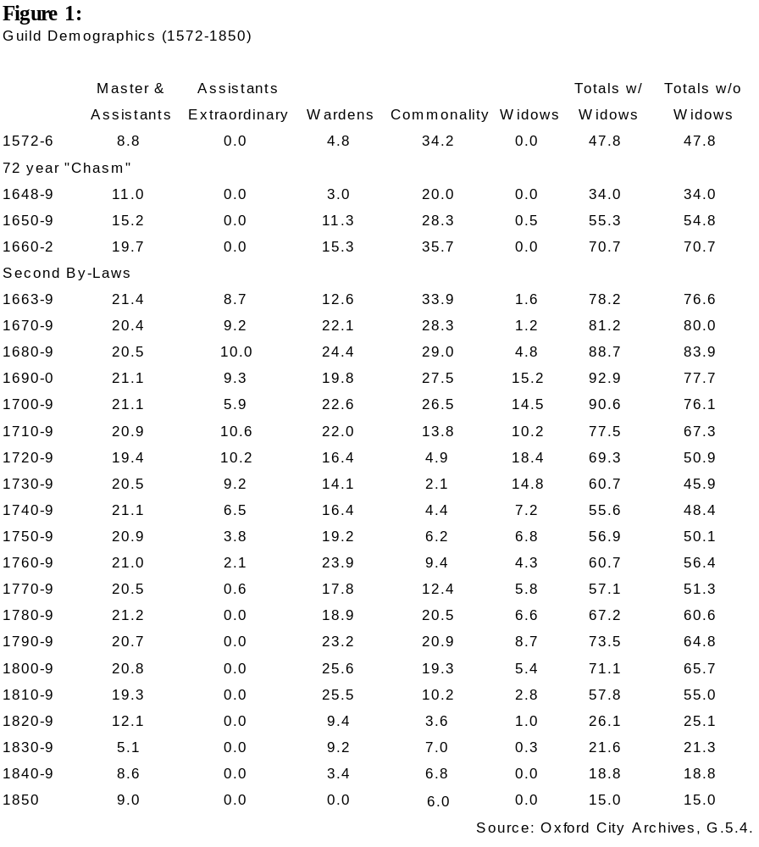
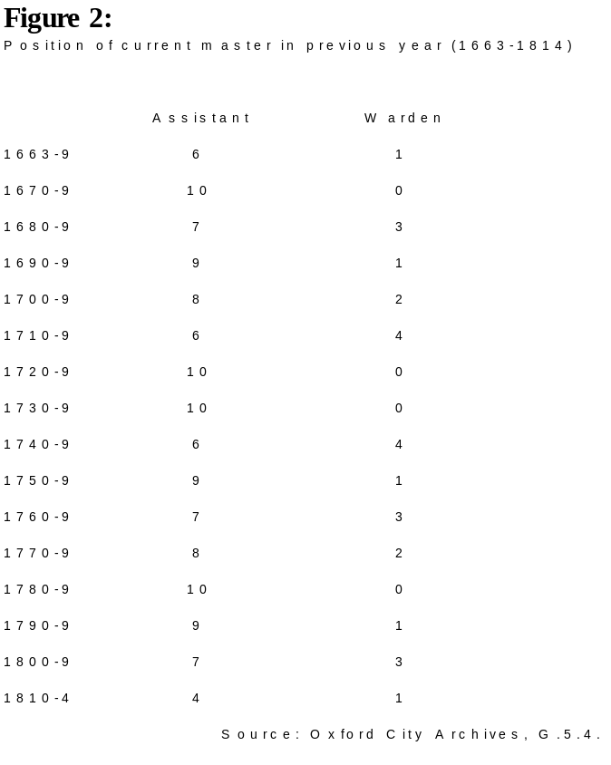

II
Historical Simulation

In constructing my computer simulation of an Oxford mercer’s life in early modern Oxford, I divided my work into four separate categories: business, investments, society, and family. By addressing these aspects of a shopkeeper’s life individually, accurate historical reconstruction became much more feasible. However, because these four categories were often interrelated, I needed to weave them together. The most important variable I use to hold the simulation together is social status. This variable is affected by a number of factors, including living standard, wealth, and family connections. In turn, a shopkeeper’s status affects how much business his shop generates, what interest rates he can receive on loans, how quickly he will rise through the guild, and numerous other facets of the simulation. Most of these causes and effects are discussed below, but the easiest way for a shopkeeper to raise his status is by raising his family’s living standard. The simulation provides five levels of daily life: ‘tight,’ ‘frugal,’ ‘moderate,’ ‘comfortable’ and ‘extravagant.’ Each one costs progressively more, but the more luxurious life one leads, the faster one’s status will rise. I have calculated living standards using Gregory King’s data, which estimates the living expenses for a shopkeeping family to be 9.10.0d. per head in 1688. Thus, this sum is the cost per head of a family living with a ‘moderate’ standard of living.
William Davis, our hypothetical mercer, starts the simulation in 1660 as a 22-year old who has just finished his apprenticeship and wants to open his own retail shop within the city of Oxford. His parents have advanced him 40 pounds to start his business, which reflects the fact that nearly all new businesses relied up familial resources for capital. Further, Davis starts with a rented retail shop he has just acquired within Oxford. A database records all the buildings in Oxford, and his first shop will be randomly chosen from among the smaller shops available for rent. Our mercer also starts out with ten pounds worth of domestic goods, which is estimated from the fact that London business households with less than £500 in wealth held £59 in domestic goods at the time of the head of the household’s death. At this point, the user needs to decide how William Davis can best use his £40 in cash to succeed in Oxford’s business community. Also, as time passes, the shop may be passed to William Davis’s widow or descendants upon his death, so the simulation might continue for the new shopkeeper. However, the simulation will end in 1750 because my data model does not include the later half of the eighteenth century.

Business
In this section, I will describe how I simulated the economic life of an Oxford shop. However, before looking at how shops actually operated, I need to determine exactly what a retail shop in Oxford sold. The town of Oxford itself was one of England’s larger provincial urban areas during this period, having an estimated population of 10,000 in the 1660’s. By comparison, Exeter had 9,400 residents, Birmingham had 6,000, and Cambridge had 9,000 during this same decade. However, Oxford was not quite large enough to be considered one of England’s leading urban centers; in the seventeenth century Peter Heylyn wrote of Oxford as being a “first city of the second rank.” Thus, Oxford’s characteristics reflected both an urban environment and a provincial life. Naturally, a retail shop in Oxford would have shared characteristics with both urban and country shops.
In her book, The Pre-Industrial Consumer in England and America, Carole Shammas provides a thorough examination of the variety of products a provincial shopkeeper would stock. By examining the inventories of 50 retailers in small provincial towns between 1560 and 1740, she divided their goods sold into six different categories:

Cloth, haberdashery (thread ribbon, lace, buttons, etc., and clothing accessories such as gloves, scarves, hats, and stockings), garments (gowns, shifts, petticoats, suits, breeches, jackets, coats), groceries (imported plant foodstuffs such as sugar, tobacco, tea, coffee, chocolate, rices, spices, dried fruits, dyes, and medicines), provisions (regionally obtained foodstuffs such as grains, cheese, butter, meat, salt, beer, plus types of fuel such as candles and coal), and other (mostly tableware, other metalware, stationery, books, and gunpowder).
Because shops in smaller towns would be less specialized than shops found in Oxford, I will use Shammas’s categories to specify what goods William Davis will be able to sell. However, I have made two modification to her system. First, because 47% of the retailers in her sample had at least 60% of their stock invested in cloth, I have divided that category into ‘linens’ and ‘woolens’ to add detail to the simulation. Moreover, these new categories should bring an extra level of realism as linens and woolens tended to sell better in the summer and winter, respectively. Also, I have eliminated the ‘other’ category because these goods had a small enough representation in her data sample to be considered negligible.
The next question to answer after determining exactly what variety of items an Oxford mercer might sell is how specialized William Davis’s stock should be. The 50 retailers in Shammas’s sample used a variety of occupational designations, including mercer, grocer, draper and haberdasher. However, the real story is told by their actual inventories; using my new categorical distribution, 53% held goods in at least three categories, and 86% held goods in at least two. Thus, few of these retailers were willing to limit their stock to just one product. One of the most important reasons for this diversification was protection in case the market price of one type of good plummeted. Nonetheless, shopkeepers in England’s larger cities were more likely to specialize than their more provincial counterparts. Certainly, in London, the differences between a draper and a mercer were clear. In a report titled The Trade of England Revived from 1681, the unnamed author laments that in much of England the distinctions between the various shopkeeping trades were unclear as “every trade cannot be distinguished as they are in London.” Accordingly, in the simulation, the most successful Oxford shops will be ones which have a diverse range of products as well as having considerable depth in a few categories. Obviously, this ideal will only be possible is William Davis is able to use a shop capable of stocking a large quantity of goods. This fact is reflected in Shammas’s data as the 13 retailers in her sample with over £200 worth of wares averaged having items in 4.4 of my stock categories.
Moreover, as a mercer, William Davis belonged to the least specialized branch of shopkeepers. Mercers were retailers “who dealt in both cloth and groceries as well as other goods.” Oxford’s three leading distributive occupations were mercery, chandlery and drapery, of which the later two were much more specialized occupations. During the sixteenth century, Oxford shopkeepers stopped calling themselves grocers, as the trade was usually practiced with mercery. However, as mentioned in the last chapter, the lines between the different distributors were blurry as a tradesman referred to as a mercer in one source might be described as a draper elsewhere. Still, the important point as far as the simulation is concerned is that William Davis will have considerable freedom in deciding exactly what type of product he chooses to sell.
Now that we have determined what an Oxford mercer might sell, our next area of inquiry will be how these shopkeepers acquired their goods. As a retailer, William Davis would have relied upon wholesalers, most of whom would have been based in London. The standard practice of the time was for wholesalers to allow beginning tradesmen to buy half of their goods on credit. William Stout, a Lancaster grocer, recorded how he started his business career in 1688 by traveling to London to buy “goods to the value of two hundred pounds or upwards and paid each of them about halfe ready money, as was then usual to do by any young man beginning trade.” At what interest rate was this credit extended? Peter Earle estimates that the rate was “offered at a rate higher than the maximum legal rate of interest and often at three or four times the maximum rate.” Thus, I estimate that the average interest rate was approximately twice the maximum legal rate. This percentage would be higher for beginners and lower for established tradesmen. Accordingly, the rate of interest at which William Davis is initially able to buy wholesale at the beginning of the simulation will be around 15%, two and a half times the maximum legal rate of 6%.
After acquiring goods from wholesalers, the next question an aspiring shopkeeper faced was how high to mark up prices. Unfortunately, this question is one area in which I was unable to find a statistically relevant source of information and had to piece together what I was able to find to create a reasonably realistic model. Richard Grassby does provide a few examples: Robert Gray, a London retailer, marked up his goods by one-third; Abraham Rhodes of Manchester had a mark-up of 26%. Therefore, I am estimating that a typical mark-up for a retail shopkeeper was approximately 30%. I have interpreted that fact to mean that in the simulation, barring other considerations such as workforce and shop conditions, if William Davis maintains a 30% mark-up, he will sell off close to half of his stock each season. If he lowers his mark-up, he will sell goods at a faster rate, and if he raises his mark-up, the opposite will occur. Further, this percentage adjusts according to the value of a product. More expensive products, such as garments, can be marked up at a higher rate because the customers will come from among the richer townspeople. The opposite is also true of cheaper goods.
Moreover, the user will need to determine what rate of interest William Davis will charge for trade credit. The rate chosen will directly affect what percentage of sales are through credit; by lowering the interest rate, cash-strapped townspeople will take advantage of William Davis’s leniency. Sales will increase, but a higher percentage of sales will be on credit, which could trickle back slowly or never at all. Trade credit was an essential aspect of retail shopkeeping life; Earle describes credit as a “central feature” of the retail economy. He goes on to describe the operation of retail credit in the following way:

Most customers paid sooner or later and the seller would be better off than if he had refused them credit. However, once weeks of non-payment turned into months, negotiations would take place between seller and buyer involving the latter in a substantial interest payment, the refusal of further credit being a useful lever to obtain profitable terms for the credit already given.
The interest rate would certainly be higher than the maximum statutory rate of interest and probably slightly higher than the average interest for a wholesale transaction as extending credit to businessmen was a better risk than extending credit to the average retail customer.
Moreover, trade credit played an important role in shopkeeper’s dealings with gentlemen, who invariably demanded credit for their purchases, an important fact for an Oxford shopkeeper as the town developed into a tourist area in the late seventeenth century. Accordingly, garments, which are the highest priced items William Davis can sell, are more affected by the level of credit extended than the other five categories of goods. The danger of extending too much credit, of course, was that the debts would never be repaid; Jacob Vanderlint suggested in 1734 that a shopkeeper should expect bad debts to absorb 2% of trading capital each year. The simulation uses this figure but adjusts it according to the rate of interest extended as only desperate customers would take out trade credit if the interest rate is excessively high. The losses could add up to a considerable sum if shopkeepers extended out too much credit; William Stout, the Lancaster grocer mentioned earlier, lost £220 by 248 bad debtors during his first nine years of business.
Before continuing, I need to discuss the data model I use to represent the shop. I have defined a quantity of stock which I will call an ‘unit’ as the amount of goods which would occupy a certain physical space, such as one cubic yard. Thus, in the simulation, William Davis buys his stock in ‘unit’ increments. Because certain categories of items are more expensive by volume, they cost more per ‘unit.’ For example, because garments are the most finished product a retailer would normally sell, they cost the most per ‘unit.’ In other words, one cubic yard of garments would be worth a great deal more than one cubic yard of provisions, such as grain or cheese. Woolens were generally more expensive than linens, so they cost more per ‘unit.’ Groceries cost a bit more than provisions as the former were mostly imported foodstuffs while the latter would be produced locally. The exact price I set for an ‘unit’ of each of the six categories was a somewhat arbitrary process as the physical size of an ‘unit’ is not defined. However, what is important is that I maintain the correct ratio between prices. Gregory King estimated that most garments sold at 15-20 shillings while woolens and linens usually sold for 1-3 shillings per yard during the same period. Thus, I price one ‘unit’ of garments at approximately four times the value of linens and woolens, less than the ratio between King’s prices as woolens and linens can be stored more densely than garments. Haberdashery falls somewhere in between as a finished products not quite as valuable as garments. Food products such as meat and cheese usually cost half a shilling per pound, so although one pound of food does not exactly correspond with one yard of cloth, an ‘unit’ of provisions or groceries will be priced less than an ‘unit’ of woolens or linens.
While my pricing system may appear overly arbitrary, I adjust the size of the retail shops available to William Davis to make these prices realistic. The average shop in the simulation has a capacity of 75 ‘units.’ By ‘capacity’ I mean the number of units which that particular shop can hold in stock at any one time. Peter Earle estimates that the average London textile retailer held 25.9% of their assets in stock. Grassby estimates that the average provincial businessman was worth approximately £840, and because shopkeepers were among Oxford’s wealthiest townspeople, we can estimate that a successful Oxford mercer would be worth around £1,000. Thus, if this hypothetical mercer held one of the average Oxford shops with a capacity of 75 ‘units’ and had £250 of stock (in accordance with Earle’s estimation), we can calculate that one ‘unit’ of stock would be worth £3.6.8, which is the price I use for one ‘unit’ of woolens as the value of woolens is closest to the middle of a continuum stretching from inexpensive provisions to costly garments. Consequently, all other products are priced relative to this median value. Moreover, prices were not constant during this period. Although inflation led to rapidly rising prices during the sixteenth century, inflation was fairly constant during our period. The fluctuations which did occur were usually within 10% of some mean value, and market prices change accordingly within the simulation.
Also, to run his shop more efficiently, William Davis will need to hire journeymen and enroll apprentices. The more ‘units’ the shop holds, the more workers will be necessary to keep the shop working at full efficiency. Each journeyman will be able to maintain a certain number of ‘units’ within the shop. A wife will also be able to help but can maintain fewer ‘units’ than a journeyman because of her lack of training. Because of their age and demand on the shopkeeper’s time for teaching, apprentices will be able to maintain even fewer ‘units’ than a wife. Gregory King calculated that in 1688 laboring families earned £15 each year, which is the level I set journeymen wages. Further, wages rose about 5% each decade during this period, which is reflected in the simulation. For apprentice premiums, I have examined a listing of Oxford apprentice rolls from the eighteenth century. Of the 33 mercers’ apprentices who recorded their premiums in the rolls, the average value was £77 with a few reaching £150. However, the cost of premiums rose considerably during this century, and in 1660 when the simulation begins, the average premium would have been lower. Grassby remarks that in 1681, premiums for the provincial shopkeepers’ apprentices were £50-60. Naturally, more successful tradesmen could charge higher premiums while new shopkeepers would have difficulty attracting apprentices. However, Christopher Brooks estimates that somewhere between one-third and one-half of all apprenticeship ended prematurely, often because of the harsh living conditions apprentices were forced to endure. Oxford’s guilds also tried to control the number of apprentices to protect the journeymen, so if William Davis enrolls too many, his social status will suffer.
Once William Davis has bought his stock, set his prices and established his workforce, he is ready to operate his shop. The simulation works by season. In other words, each season the user can learn how many ‘units’ were sold as well as the corresponding profit. The user can then adjust prices or change his upcoming purchases accordingly. The algorithm used to determine how much William Davis’s shop sells in each of the six categories is complex but can be broken down to a finite number of variables. These variables include price mark-up, shop efficiency, trade credit extended, variety of products, product quantity, shop conditions and status. The first five variables have already been discussed earlier in this section, but they all play a role in determining how many ‘units’ are sold in each category. The last two variables refer to the appearance and reputation of the shop.
Shopkeepers had to concern themselves with how attractive their shop was to customers, which naturally would affect sales. The reputation of the shop depended largely upon the social status of the shopkeeper. Naturally, this status level was largely a reflection of the success of William Davis’s business. As Grassby writes,

Once a business was established, profits could grow to cover overheads and enable some capital to be accumulated. Money and reputation attracted more business and cheaper funding. Every business had its point of take-off, after which it matured and became self-generating.
Success bred success, and thus, if the user makes wise choices, William Davis’s wealth will grow faster and faster. Finally, the overall economy of Oxford will affect sales as well; as the city’s economy slowly recessed during the early eighteenth century, life as a shopkeeper will gradually become more difficult.
Indeed, if William Davis (or one of his descendants) becomes wealthy enough, the simulation allows the shopkeeper to expand into wholesale. In order to succeed, the user will need to find at least one warehouse to store goods for sale. The operation of wholesale trade is similar to retail, with the major differences being mark-ups and credit. As a wholesaler, the shopkeeper will be competing with Londoners. Accordingly, the mark-ups necessary for success will be significantly lower than retail mark-ups. I estimate that the mark-ups should hover around 10%, which is consistent with data found by Grassby. Also, wholesalers had to be willing to live with a high level of trade credit; 53.76% of London textile wholesaler’s assets was trade credit. The interest rate charged should be similar to that which William Davis received as a retailer from his wholesale suppliers. Thus, life as a wholesaler depends largely on avoiding bad debts and surviving with over half of one’s assets temporarily unavailable.

Investments
As the simulation proceeds, if William Davis becomes so successful that he begins acquiring excess capital, two major investment options are open to him: loans and property. Both of these options were discussed at length in the first chapter, so I will spend most of my time in this section discussing how the simulation models the historical data. These two options comprised the vast majority of investments taken by businessmen of moderate wealth during our period. London businessmen invested 32.1% of their assets in property and 33.3% in loans and mortgages. The other categories included government debt, shipping and company stocks and bonds. However, these investment options were monopolized by the richest businessmen, so as they likely were remote options for Oxford shopkeepers, I have not included them in the simulation.
The loan market consisted of two possibilities, personal loans and mortgages. As mortgages were secured by property, they earned a much lower interest rate than most personal loans. In contrast, personal loans could be made at very high rates, much higher than the statutory limit of 6%. Numerous methods existed for bypassing the usury laws, such as subtracting a “premium” from the principal before transferring the loan. In reflection of this fact, the simulation allows loans at any rate, but loans with a very high interest rate are much more likely to become irrecoverable. Plus, if William Davis offers loans at very high interest rates, his status will suffer. For Oxford’s money market, I am estimating an average interest rate of 4-6% for mortgages and 6-10% for loans. William Davis will also be able to raise capital through loans and mortgages for similar rates, depending on his wealth and social status.
The simulation’s property market includes both urban and rural property. Lands are available to William Davis in thirty villages spread throughout Oxfordshire and Berkshire. Buildings are available within Oxford itself. Ownership of property increases Davis’s status although land holdings bring a higher level of respect. Two types of tenure are available: freehold and leasehold. Purchasing a freehold functionally equated to buying a property, and for land, the typical cost was 20 times annual rack rent. However, the actual multiplier gradually rose from 18 to 27 between 1660 and 1750, and in the simulation, I will use the data compiled by Christopher Clay in his article “The Price of Freehold Land in the Later Seventeenth and Eighteenth Centuries” to create an accurate chronology. Because buildings required higher maintenance costs, the multiplier for freehold urban property would be lower, approximately three-quarters of the land multiplier. Further, the rate of change for this urban multiplier will roughly follow the changes Clay outlines in his article. Also, if William Davis is able to purchase two pieces of freehold lands which are adjacent to one another, he can enclose them, which should double the rents but significantly damage his social status.
‘Leasehold’ lands in this simulation encompass both lifeleaseholds and copyholds for lives as those two tenureship were very similar. Lifeleaseholds were common in western England, and copyholds for lives were used elsewhere. Clay discusses the similarity between the two in his article “Lifeleasehold in the Western Counties of England 1650-1750:”

A large proportion of the land held by lease in the western half of the country in this period had thus been copyhold in the recent past. Indeed, essentially western leasehold was copyhold . . . In very many practical respects the two types of tenure were virtually identical, and the terms of the leases continued to reflect what custom, in a non-technical sense, prescribed.
Thus, as Oxford straddled the line between western and eastern England, both type of tenureship were likely available, so I have grouped them into one category. Most of the leases were determinable by three lives, renewable for a reserved rent which was a small percentage of the rack rent. Clay suggests that during our period, the cost of ‘leasehold’ lands was about 12-16 times the rack rent. I will use this figure in the simulation although the multiplier will rise and fall in accordance with the fluctuations of the freehold land multiplier. Also, for adding new lives to a lease after death, I will use the standard rate of two times rack rent. Leasehold urban property is much more straightforward. Within Oxford, the standard lease term ran for 40 years, renewable after 14 years for one year’s rack rent. Earle’s estimates for the gross profits from leasehold property in London suggests that purchasing urban leaseholds cost between 8 and 12 times rack rent. The multiplier in the simulation will use this range but change according to the changes in the multiplier for freehold buildings.
For rack rents, I am using Gregory King’s estimates for land from 1695: 5.10d. per acre for arable acre and 9 s. per acre for pasture. Farm rents also appear to have been slowly decreasing throughout England during our period, with the exception of a twenty year period from 1693 until 1713. For urban rents, I have used T. C. Dale’s composition of London rents in 1638, most of which fell between £5 and £20. While a number of these rents may have been deflated to avoid London’s taxation system, building rents in Oxford would have been lower anyway, so I will use these figures as a rough guide. An examination of Oxfordshire inventories from the late sixteenth century reveals that 90.7% of Oxfordshire’s building had no more than six rooms. This number would have grown in the next century, so if we divide a high rent of £20 by a large Oxford building of 8 rooms, we get a rent rate of £2.10.0 per room, which is the rate used by the simulation. Moreover, rents were increasing in Oxford until the 1690s when they began to stagnate.
Once William Davis has purchased a piece of property, he would most likely decide to rent out his holdings to tenants. Freeholds would return a relatively stable percentage of the initial investment through rents, and lifeleaseholds and copyholds for lives were little different as Clay emphasizes:

[T]he readiness with which the title to copyhold lands could be proved, and the simplicity and cheapness with which it could be conveyed by means of surrender and admission in the manor court, meant that it was a particularly suitable form of property for the man of modest means to buy as an investment. Numerous urban business men, professional men, and their widows thus acquired copyhold or, in the west, life leasehold.
Rents from each specific holding would change slowly over time, lagging behind the general rise and fall of property rents as neither the landlord nor the tenant were willing to accept a system by which rents were completely renegotiated each year. Furthermore, as landlord, William Davis will be responsible for maintaining the condition of his properties, which also affects rent and value. As a proportion of rent collected, repair costs were normally around 7-10% on lands. For buildings, this proportion would likely be double that percentage. Moreover, in the simulation, William Davis can spend lump sums to upgrade the condition of his property if his holdings fall into disrepair. Finally, the rents Davis collects from his property will be taxed by the government. King calculated that the tax rates, as a percentage of real as opposed to assessed values, were 13% for land and 15% for buildings. However, these rates were calculated in 1695 at a time of high taxation due to war with France, so in the simulation, tax rates will follow their historical trajectory, peaking in the 1690’s and 1740’s.
In order to be able to operate his business, William Davis may need to rent his shop or warehouses. These buildings are available at the same rack rents which determine the price of freehold and leasehold buildings. One danger for urban property is fire. Until around 1710, fire insurance had not spread to the provinces, so the simulation does not make insurance available until that time. Further, purchasing fire insurance will also insure the shopkeeper’s goods. For insurance costs, I am using an example from 1682 which charged approximately 0.3% of the amount ensured each season.

Society
This section will deal primarily with city politics as Oxford’s shopkeepers’ guild was discussed extensively in the first chapter. Oxford’s inner council, known as the Thirteen, was composed of eight assistants to the mayor, four aldermen, and the mayor himself, who was chosen from among the alderman and assistants. During our period, members of the inner council would repeat terms as mayor but only after a four year interval. Below the inner council were three groups, bailiffs, chamberlains, and the common council. The normal progression was election to the common council, then to chamberlain, and finally to bailiff. In the simulation, William Davis will be able to progress in such a fashion through the city council if his social status rises high enough. Indeed, if his status reaches a high enough level, he has a chance to be elected one of Oxford’s two M.P.s. Accordingly, as William Davis climbs the ladder of offices, his status will rise as well. Furthermore, as a mercer, William Davis possesses a distinct advantage for penetration of the city council, which was dominated by the wealthier victualling and distributive trades. From 1700-1739, for example, distributive tradesman, most of whom were mercers, accounted for 23% of the councillors. However, as William Davis plays a progressively more active role on the city council, his ability to work in his own shop will decrease, causing him to need more journeymen and apprentices.
Oxford’s guild slowly lost power during this period, but in 1660, when William Davis originally opens his shop, he will be forced to join the guild. As the simulation progresses into the eighteenth century, avoiding entrance into the guild will be possible, but unadvisable as joining the city and guild will raise one’s status. Admission into the city’s freedom for former apprentices was 9.6d. while entrance into the guild will vary between £1-3 depending on the guild’s size. In other words, when the guild is large early in our period, and Oxford’s economy is strong, guild admission will be more expensive. Accordingly, the guild’s size in the simulation will grow and shrink as described historically in the first chapter. Quarterage depended upon one’s position within the guild: assistants paid 4.0d., wardens paid 2.8d., and members of the commonality paid 2.0d. William Davis’s social status controls his ascent through the ranks of the guild, and higher positions will consequently raise the shopkeeper’s status as well. Just like a position in the city council, serving as warden, master or assistant will limit William Davis’s ability to work within his own shop. Further, if Davis is elected warden, he will be responsible for a guild banquet which was, in the words of Ian Archer, a chance to “advertise [his] status.” Thus, the more capital he sinks into the feast, the higher his status will rise. Finally, membership within the guild allows William Davis to find loans at relatively low interest rates from fellow businessmen.

Family
If the simulation is going to progress beyond the life of William Davis, an heir will have to be determined for his shop. Three inheritance options exist to keep the shop within the family: the widow, a son, and an apprentice who has married a daughter. All three options did occur historically. Mary Matthew, for example, married two mercers and continued business long after her second husband died in the late sixteenth century. As long as the widows continued paying quarterage, they could conduct the trade of their dead husband; indeed, they could even enroll apprentices. Mary Prior has found that during the period between 1520 and 1800, 20 different Oxford widows conducted business in the distributive trades.
Having a son adopt the family business usually involved enrolling the son as an apprentice. Examples of this practice can be found within the Oxford’s apprentice rolls; in 1722/3, Henry Wise enrolled his son Thomas as an apprentice. As Oxford’s Mercers’ and Woolen Drapers’ Guild eventually elected Thomas Wise master in 1743, he obviously continued mercery within Oxford. Whether he took over his father’s shop is unknown but that possibility is certainly conceivable. Moreover, Prior stresses that as the Oxford economy stagnated in the middle of our period, more sons began following their fathers in their trades.
The final option was for the shop to pass into the hands of an apprentice who accordingly had married the shopkeeper’s daughter. In Earle’s words, “The scenario of the apprentice who married his master’s daughter and took over the business was also one that happened in reality as well as fiction.” While this option was more likely for a family without sons, any family with daughters could follow this route. Finally, as head of the family, William Davis cannot force his son to become his apprentice or his daughter to marry an apprentice. Instead, the simulation allows the shopkeeper to “encourage” his children to follow such options. Such encouragement is no guarantee but provides a reasonable probability for these scenarios.
William Davis’s choice of marriage partners depends upon his status, and as outlined in the first chapter, the expected dowry should double his current wealth. Also, Davis’s status will rise upon marriage, but in accordance with the status of his bride’s father. In other words, marrying the daughter of a gentleman raises one’s status much more than marrying the daughter of a husbandman. Statistics for family life are drawn from The Population History of England 1541-1871 by E. A. Wrigley and R. S. Schofield, English Population History from Family Reconstruction 1580-1837 by Wrigley, Schofield, R. S. Davies and J. E. Oeppen, and Gregory King’s calculations. These statistics include age at marriage, mortality, and fertility. The mean ages for first marriage during our period were 27.65 for males and 26.35 for females. Fertility and mortality are more complex issues. The overall sterility rate appears to have been around 4% per marriage. King estimated that most families had 2.17 children, which meant that considering high child mortality rates, most fertile families probably had 3 or 4 children. The Gross Reproduction Rate, which is a measure of how many adults each marriage produced, did hover between 1.9 and 2.4 during our period. Life expectancy during our period hovered around 32 and 36 years, with child mortality rates of 25%-27%. I have tried to simulate these statistics accurately within my simulation.
For inheritance, I have stuck closely to the rule of thirds. First, funeral expenses and the widow’s chamber are subtracted from the estate. Next, the deceased’s creditors will get a chance to collect their debts from the estate. Of the remaining wealth, one-third will go to the widow, the next third will be split evenly among the children, and the final third, known as the “dead man’s share” will be bequeathed according to the will. In the simulation, I give the user the ability to choose both the next shopkeeper and the percentage of his inheritance which will be passed to this person. A certain, minimum percentage is required depending on the next shopkeeper’s relation to the old shopkeeper. On top of this minimum, the user could decide to distribute any percentage of his “dead man’s share” to the heir of his shop. However, if other children exist and the user decides to pass all of the “dead man’s share” to the son who will inherit the shop, this new shopkeeper’s status will suffer from family spite.
As head of a family, William Davis will also be responsible for providing premiums, portions and advancements when his children mature. Refusal to do so will hurt the shopkeeper’s social status. When you do agree to pay for a premium, portion or advancement, the simulation will give you one season to raise the capital. Also, as families were the principal sources of low-interest loans for starting businesses, when William Davis starts acquiring excess capital, relatives will start asking for loans. Refusing the request will significantly damage the shopkeeper’s status. Concerning this issue, Margaret Hunt provides the example of Samule Marriot who was disowned by his family for refusing to invest in his brother’s business. Conversely, the best place for William Davis to find low-interest loans early in his career is within his own family. The simulation places a limit on exactly how much money the user can take from his own family, but this route is certainly the best way to raise quick capital.

III
Simulation Instructions

When the simulation starts, the Main Screen should become visible. From this screen, most of the functionality necessary to operate the shop is available. The Main Screen should be titled “William Davis’s Shop” when the application begins. Underneath this title is the Menu Strip, from which the user can access the four different views: Finances, Purchases, Shop, and Stock. One of the words in the Menu Strip should be underlined, designating which of the four views is currently visible on the Main Screen. To temporarily examine a different view, drag the mouse over the corresponding word in the Menu Strip. To actually switch to that view, click once on the corresponding word. Once the view has changed, the word should become underlined to signify the new view. To close the Main Screen and thus end the current simulation, click on the box in the upper-left corner of the window. Before closing, the application should prompt the user to specify whether the current simulation should be saved.
Next to the Menu Strip is the New Turn Button, which controls the passage of time in the simulation. The simulation progresses by season, so by clicking on this button, three months will pass. During this time, the shop will operate according to the parameters set by the user. The shop will sell goods by retail at the prices set on the Shop View. Items will be bought for sale during the next season according to the orders given on the Purchases View. If the user decided to look for a spouse on the Family Screen, the shopkeeper may be able to decide upon a possible marriage. In other words, the basis for the simulation’s functionality is the three month turn which the user initiates by clicking on the New Turn Button.
On the right side of the Main Screen is the Status Bar. This bar is a reflection of the current shopkeeper’s standing in the community. As the business grows and the shopkeeper gains respect, this bar should rise. However, if the shopkeeper makes a socially unfavorable decision, such as hiring too many apprentices, this bar will fall.
At the bottom of the Main Screen are the Wealth Boxes. These boxes display information concerning the shop’s current wealth. Debts are all outstanding debts which the shopkeeper has yet to repay. Cash is simply the physical cash currently available to the shopkeeper. Credits describe the current outstanding trade credit which the shopkeeper has extended to his customers. Goods are the domestic goods which the shopkeeper and his or her family owns. Assets are the sum total of all current investments, which includes real estate as well as any loans or mortgages the shopkeeper has extended to his debtors. Stock is the current value of the shopkeeper’s stock (both in shop and storage) at the price his or her wholesale providers are currently charging.

Main Screen

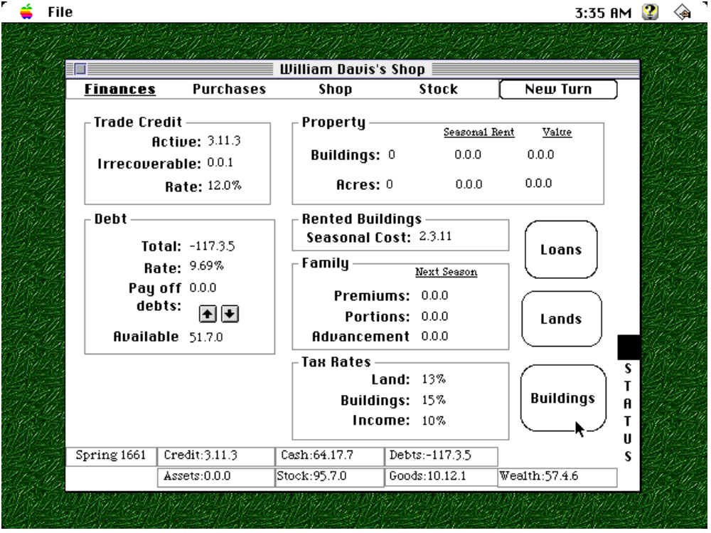

Finances View
From this view, you can examine information relating to your finances, including trade credit, debt, property, rented buildings, taxation and family expenses. You can also access the Loans Screen, Lands Screen and Buildings Screen from this view.

Main Screen

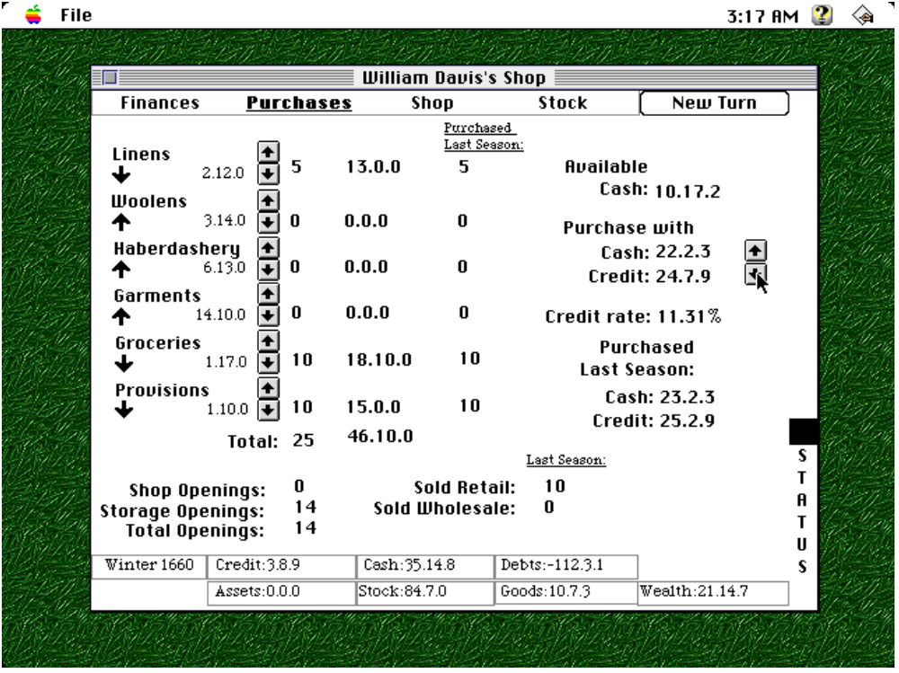

Purchases View
From this view, you can decide what goods you are going to order from your wholesaler for next season. Buttons are located on the left side of the view to change your current order. In the upper right corner, buttons allow you to choose what percentage of your order will be on credit. Below these buttons is the current rate of credit you are receiving from your wholesalers.
Main Screen

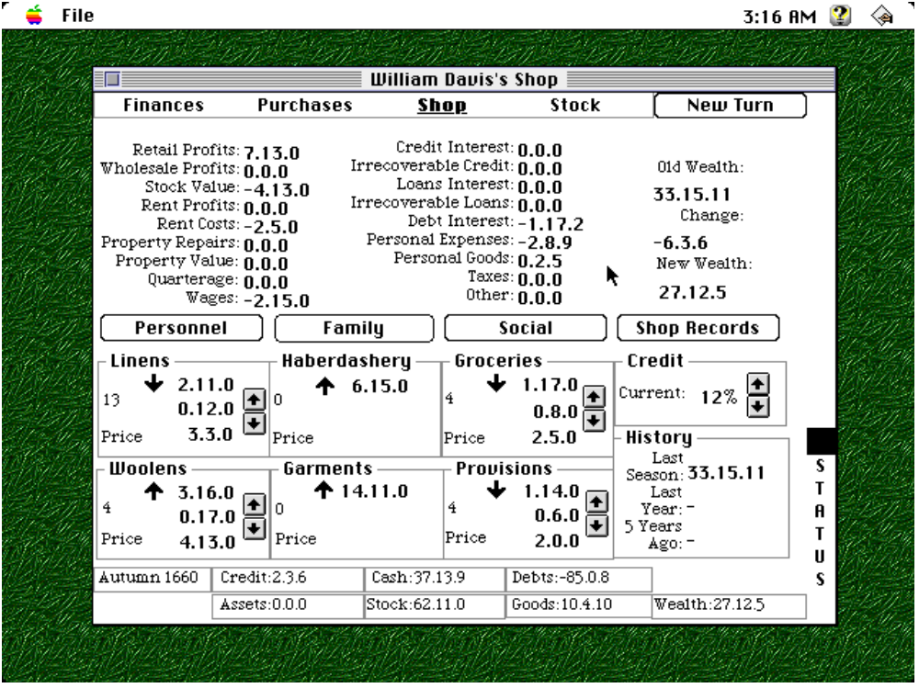

Shop View
From this view, you can set your prices for the upcoming seasons using the button near the bottom of the view. On the right side of the view is the current interest rate you are charging on trade credit you are extending to customers, which you can alter using the buttons. You can also examine your financial history from this view. Finally, you can access the Personnel Screen, Family Screen, Social Screen, and Shop Records Screen using the buttons in this view. The up and down arrows (not the buttons) next to the base costs of your stock indicate whether the base cost is above or below the expected cost. In other words, if the arrow is down, the item’s cost should rise in the future.

Main Screen

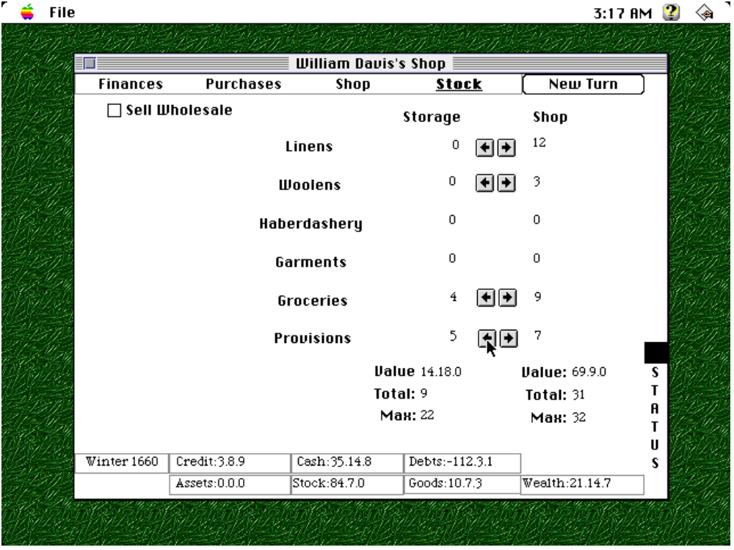

Stock Screen
From this view, you can move your stock between shop and storage. If you have stock in storage, you can also choose to sell items by wholesale. If you do, this view is where you would set your prices.

Land Screen

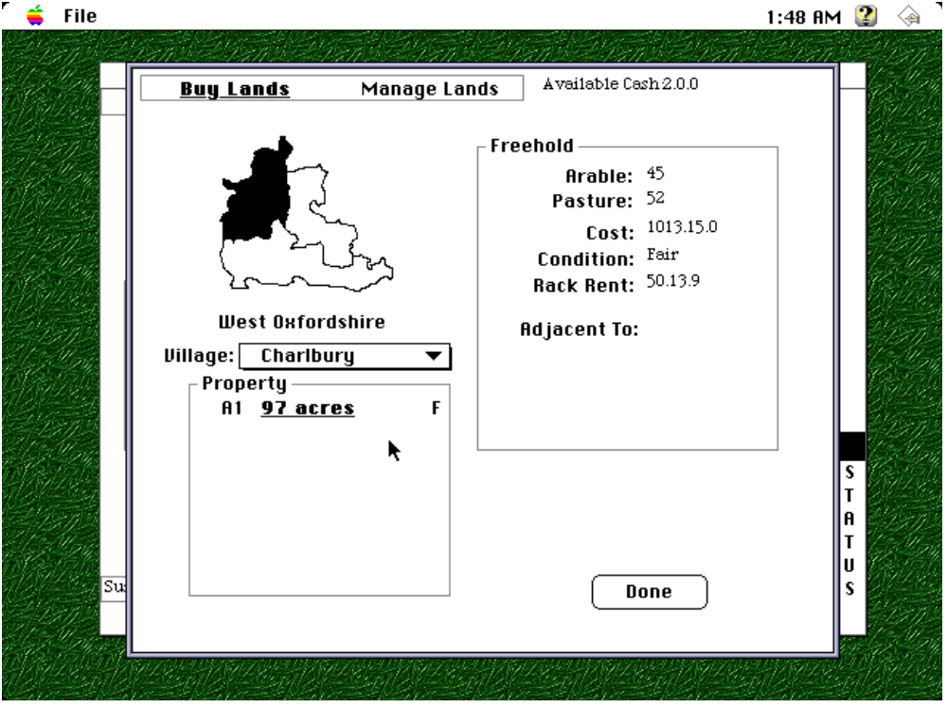

From this screen, you can examine the thirty different villages in Oxfordshire and Berkshire to purchase freehold and leasehold lands. When you own land, you will be able to manage it from this screen as well. Use the Menu Strip at the top of the screen to switch between buying and managing lands. Options include enclosure, improvement and mortgaging or selling your land.

Buildings Screen

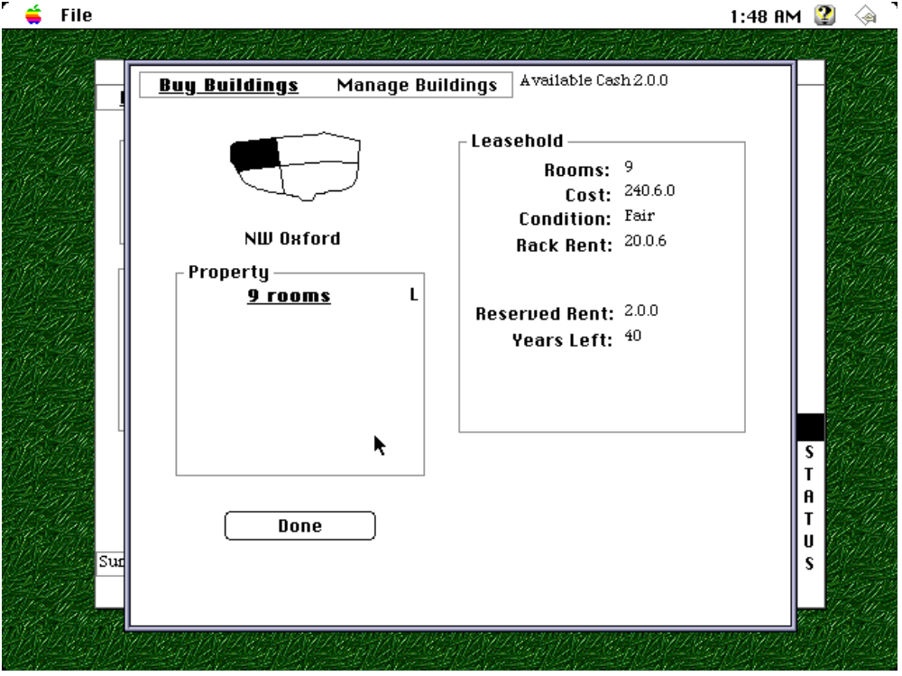

From this screen, you can examine the four different quarters of Oxford to purchase freehold and leasehold buildings or to rent shops and warehouses. When you own urban property, you will be able to manage it from this screen as well. Use the Menu Strip at the top of the screen to switch between buying and managing buildings. Options include improvement, mortgaging or selling your property and using your property if the building is a shop or warehouse.
Loans Screen

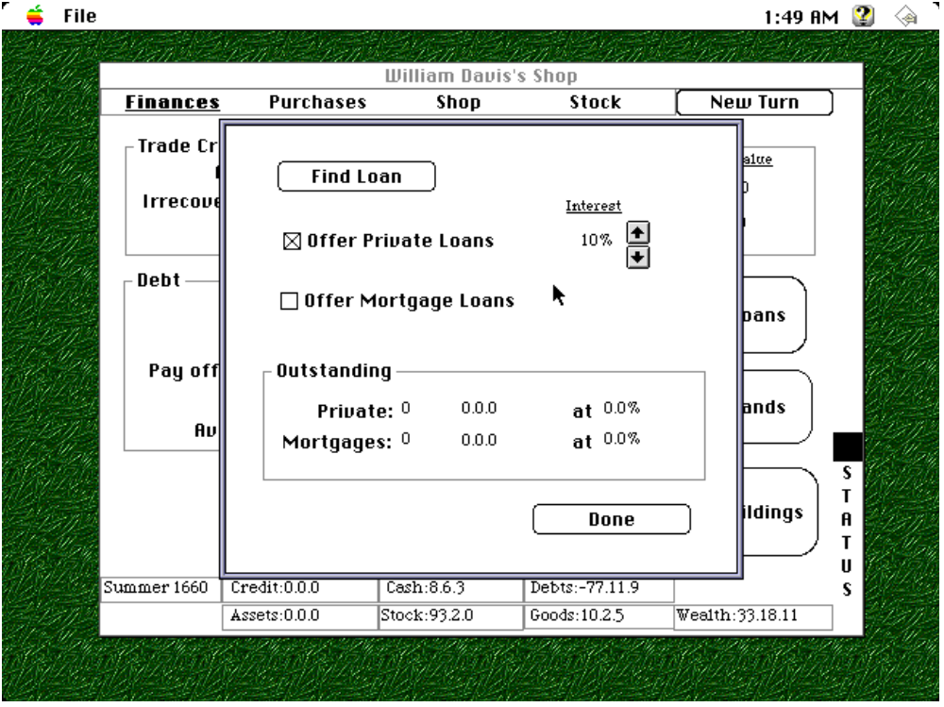

From this screen, you can try to find a private loan using the Find Loan button. You can also try to extend your own loans to various townspeople through private loans and mortgages. Buttons on the right allow you to alter the interest rate you will charge. Also, information at the bottom of the screen tells you about any outstanding private loans or mortgages you have extended.

Personnel Screen

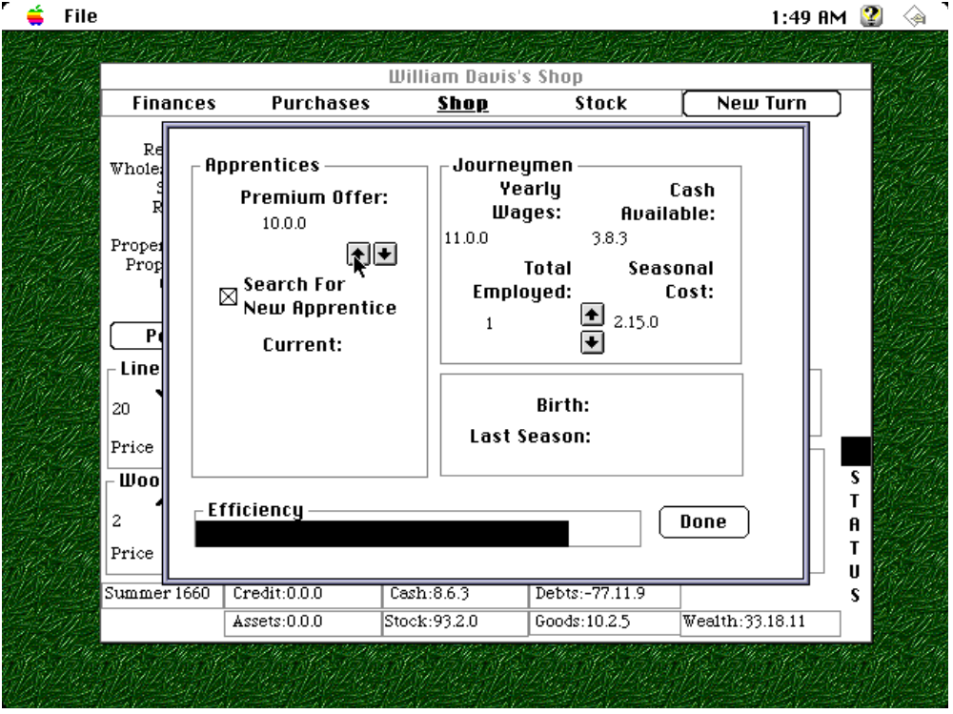
From this screen, you can determine how efficiently your shop is functioning from the Efficiency Bar at the bottom of the screen. You can also hire journeymen using the buttons on the right side of the screen. Finally, you can search for a new apprentice by clicking on the Search For New Apprentice check box in the top left corner of the screen, and you can set the premium you will charge by pressing the buttons below the check box. You can also examine your apprentices in a fashion similar to on the Family Screen above the Efficiency Bar.
Social Screen

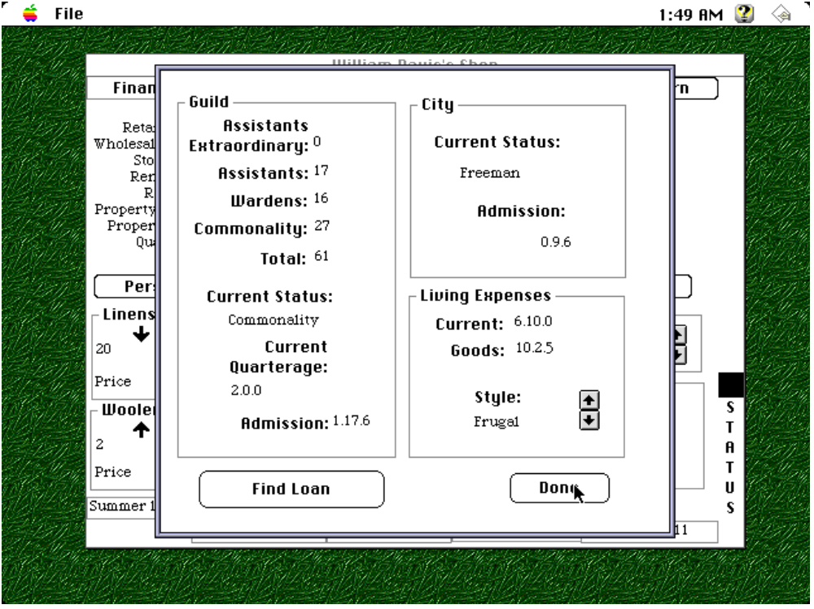
From this screen, you can examine your standing in the city government and the mercers’ guild. You can join the guild and city using the Join Guild And City button at the bottom of the screen. Once you have joined, you can try to find a loan from fellow businessmen by clicking on the Find Loan button. Finally, you can change your living standard using the buttons at the bottom right of the screen.

Family Screen

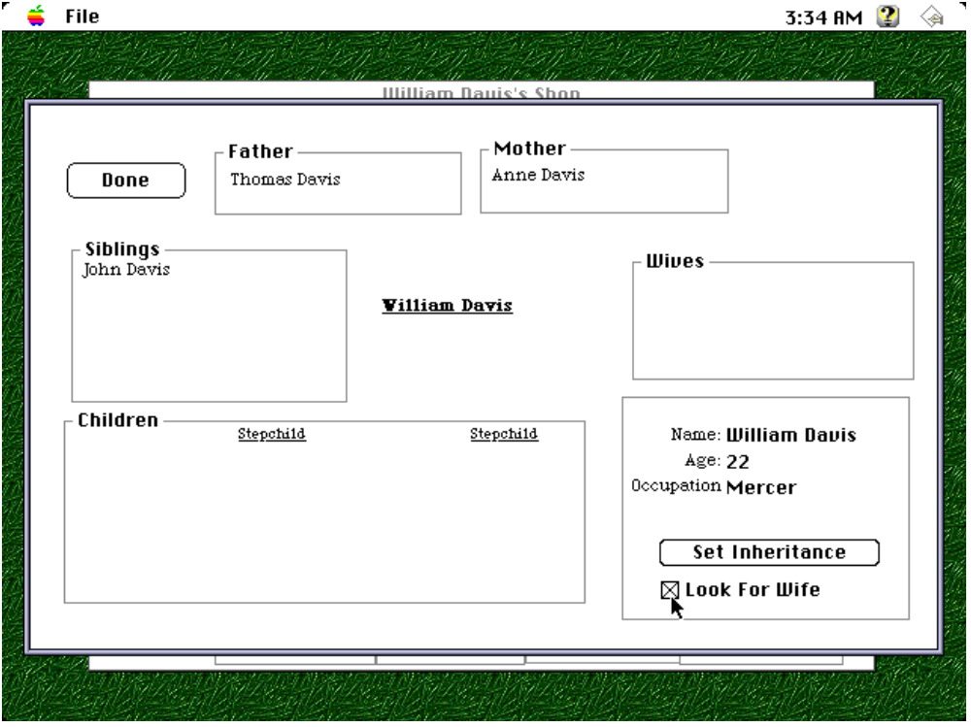

From this screen, you can examine and manage your family. To examine a person, click on his name. Information about that person will appear in the bottom right. To examine a person’s family tree, double-click on his name. To find a wife, click on the Look For Wife check box. To change your inheritance, click on the Set Inheritance button. To ask family members for loans, click on the Ask For Loan button. Other options available are encouraging your son to become your apprentice and encouraging your daughter to marry your apprentice.
Shop Records Screen

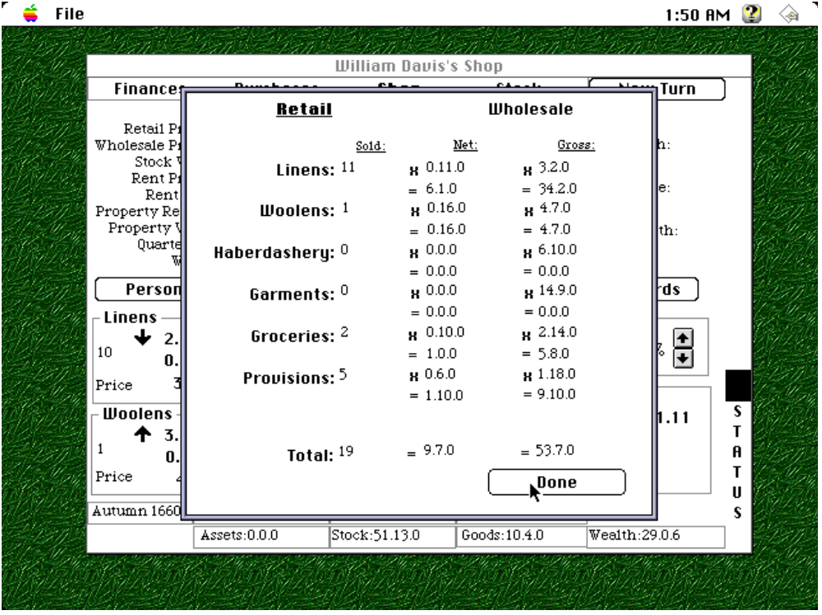

From this screen, you can examine the performance of your shop during the last season. By using the Menu Strip at the top, you can switch between wholesale and retail sales.

A Note on Saving
You can save the current simulation using the Save command under the File menu. To open a saved simulation use the Open... command from the File menu. You cannot open saved simulations outside of the application. In other words, double-clicking on a saved simulation document on you desktop will create unpredictable results as saved simulations are simply text files.

Epilogue
As I finish this project, I am astonished to realize how much I can’t describe in this paper. So many aspects of the simulation are subtle enough that they would fill far too many pages. For example, if the shopkeeper marries the daughter of a businessman, his ability to find good loans from within the business community will increase. As the simulation progresses more lands become enclosed behind the scenes, so smaller parcels of land will no longer be available for purchase. While making the simulation, I was constantly forced to make choices which seemed like splitting hairs at the time. How much status should the shopkeeper gain each season for living ‘extravagantly?’ The problem is that no method exists to know categorically the answer to these questions. In other words, only a certain portion of the data could be concrete. How could I calculate the effect of holding a city office on the shopkeeper’s business? Would the end result be better or worse? In response to this challenge, I have included as much primary information as possible and tried to develop a balanced view in response to holes in my data. For the question just stated, holding a city office will help your status which can help sales, but the time spent on the office will require the shopkeeper to hire more journeymen or to enroll more apprentices to pick up the slack. As long as I was addressing all sides of these issues, I could feel confident in my educated guesses. Thus, I have created a world which is relatively equivalent to a mercer’s world in early modern Oxford. The data has limitations, but the end result is a simulation which creates the same anxieties, successes and failure which Oxford mercers actually encountered.

Bibliography

Primary Sources

Bodleian Library
Guild Records

Corporation Records Office, Guildhall
Reports of Common Council

Oxford City Archives.
Guild Records

Oxfordshire County Archives.
Marriage Contracts
Wills
Business Records
Mortgages
Leases
Property Transactions

Secondary Sources

The Victoria History of the County of Oxford, ed. Alan Crossley. Oxford: Oxford University Press, 1979. IV.

The Victoria History of the County of Warwick, ed. W. B. Stephens. London: A. Constable, 1983. VIII.

Archer, Ian. The History of the Haberdashers’ Company. Chichester, Sussex: Phillimore, 1991.

Archer, Ian. The Pursuit of Stability: Social Relations in Elizabethan London. Cambridge: Cambridge University Press, 1991.

Berger, Ronald M. The Most Necessary Luxuries. University Park, PA: Pennsylvania State University Press, 1993.

Blackham, Robert J. London’s Livery Companies. London: Low, Marston, 1930.

Bowden, Peter. “Agricultural Prices, Wages, Farm Profits, and Rents,” Agrarian History of England and Wales, ed. by Joan Thirsk. Cambridge: Cambridge University Press, 1985. V, pt. II.

Braddick, M. J. Parliamentary Taxation in Seventeenth Century England. Suffolk, England: Royal Historical Society, 1994.

Bowden, Peter, “Agricultural Prices, Farm Profits, and Rents,” Agrarian History of England and Wales, ed. by Joan Thirsk. Cambridge: Cambridge University Press, 1967. IV.

Brooks, Christopher. “Apprenticeship, Social Mobility and the Middling Sort, 1550-1800,” The Middling Sort of People, eds. by Jonathan Barry and Christopher Brooks. London: Macmillan, 1994.

Chartres, John and David Hey, eds. English Rural Society, 1500-1800. Cambridge: Cambridge University Press, 1990.

Clark, Peter, ed. Country Towns in Pre-Industrial England. Leicester, England: Leicester University Press, 1981.

Clark, Peter and David Souden, eds. Migration and Society in Early Modern England. London: Century Hutchinson Ltd., 1987.

Clark, Peter, ed. The Transformation of English Provincial Towns 1600-1800. London: Hutchinson Group, 1984.

Clay, Christopher. Economic Expansion and Social Change: England 1500-1700. Cambridge: Cambridge University Press, 1984.

Clay, Christopher. “Landlords and Estate Management in England,” Agrarian History of England and Wales, ed. by Joan Thirsk. Cambridge: Cambridge University Press, 1985. V, pt. II.

Clay, Christopher. “Lifeleasehold in the Western Counties of England 1650-1750,” Agricultural History Review, 1981, II.

Clay, Christopher. “The Price of Freehold Land in the Later Seventeenth and Eighteenth Centuries,” Economic History Review, May 1974.

Clark, Peter and Paul Slack. English Towns in Transition 1500-1700. Oxford: Oxford University Press, 1976.

Coleman, D. C. The Economy of England 1450-1750. Oxford: Oxford University Press, 1977.

Coward, Barry. Social Change and Continuity in Early Modern England. London: Longman Group, 1988.

Davies, Matthew P., “The Tailors of London and their Guild, c.1300-1500,” Oxford University Ph.D. thesis, 1994.

Daunton, M. J. Progress and Poverty: An Economic and Social History of Britain 1700-1850. Oxford: Oxford University Press, 1995.

D’Cruze, Shani. “The Middling Sort in Eighteenth-Century Colchester: Independence, Social Relations and the Community Broker.” The Middling Sort of People, eds. by Jonathan Barry and Christopher Brooks. London: Macmillan, 1994.

Dickson, P. G. M. The Financial Revolution in England. New York: St. Martin’s Press, 1967.

Doolittle, I. G. The Mercers’ Company, 1579-1959. London: Mercers’ Company, 1994.

Doolittle, I. G. The City of London and it Livery Companies. London: Guildhall Library Publications, 1990.

Dunlop, O. Jocelyn. English Apprenticeship and Child Labour. London: T. F. Unwin, 1912.

Dyer, Alan D. The City of Worcester. Leicester: Leicester University Press, 1973.

Earle, Peter. The Making of the English Middle Class. London: Methuen, 1989.

Emery, Frank. The Oxfordshire Landscape. London: Hodder and Stoughton, 1974.

Gibson, J. S. W. “Index to Wills Proved in the Peculiar Court of Banbury 1542-1858,” Oxfordshire Record Society, 1958.

Goody, Jack, Thirsk, Joan and E. P. Thompson, eds. Family and Inheritance: Rural Society in Western Europe, 1200-1800. Cambridge: Cambridge University Press, 1976.

Graham, Malcolm, ed. Oxford City Apprentices 1697-1800. Oxford: Clarendon Press, 1987.

Grassby, Richard. The Business Community of Seventeenth-Century England. Cambridge: Cambridge University Press, 1995.

Grassby, Richard. The English Gentleman in Trade. Oxford, Clarendon Press, 1994.

Grassby, Richard. “The Rate of Profit in Seventeenth-Century England,” English Historical Review, July 1969.

Hammer, C. I. “Some Social and Institutional Aspects of Town-Gown Relations in Late Medieval and Tudor Oxford,” Toronto University Ph.D. thesis, 1973.

Havinden, M. A. Household and Farm Inventories in Oxfordshire, 1550-1690. London: Her Majesty’s Stationery Office, 1965.

Hibbert, Francis Aidan. The Influence and Development of English Gilds. Cambridge: At The University Press, 1891.

Higman, Roger. Berkshire and the Vale of White Horse. London: B. T. Batsford Ltd., 1977.

Hobson, M. G., ed. Oxford Council Acts, 1665-1701. Oxford: Clarendon Press, 1939.

Hobson, M. G., ed. Oxford Council Acts, 1701-1752. Oxford: Clarendon Press, 1954.

Hobson, M. G., ed. Oxford Council Acts, 1752-1801. Oxford: Clarendon Press, 1962.

Hunt, Margaret. The Middling Sort. Berkeley, CA: University of California Press, 1996.

Imray, Jean. "Les bones gentes de la Mercerye de Londres," Studies in London History. London: Hodder, 1969.

Kellet, J. R. "The Breakdown of Gild and Corporation Control over the Handicraft and Retail Trade in London," Economic History Review, 1957-8, X.

Kerridge, Eric. Trade and Banking in early Modern England. Manchester: Manchester University Press, 1988.

Mathis, Peter, ed. The Price Revolution in Sixteenth-Century England. London: Methuen, 1971.

Overton, Mark. Agricultural Revolution in England. Cambridge: Cambridge University Press, 1996.

Palliser, D. M. Tudor York. Oxford: Oxford University Press, 1979.

Patten, John. English Towns 1500-1700. Kent, England: Archon Books, 1978.

Pound, John. Tudor and Stuart Norwich. Sussex, England: Phillmore and Co. Ltd., 1988.

Prior, Mary, ed. Women in English Society 1500-1800. London: Methuen, 1985.

Rappaport, Steve. Worlds within Worlds: Structures of Life in Sixteenth-Century London. Cambridge: Cambridge University Press, 1989.

Rees, J. Aubrey. The Worshipful Company of Grocers. Chapman and Dodd, Ltd.: London, 1923.

Richardson, John. The Local Historian’s Encyclopedia. New Barnet, Herts.: Historical Publications Ltd., 1974.

Rudé, George. Hanoverian London, 1714-1808. Berkeley, CA: University of California Press, 1971.

Sacks, David Harris. Trade, Society and Politics in Bristol. London: Garland Publications, Inc., 1985. II.

Salter, H. E., ed. Cartulary of the Hospital of St. John the Baptist. Oxford: Clarendon Press, 1914.

Salter, H. E., ed. Oxford Council Acts, 1583-1626. Oxford: University Press, 1928.

Salter, H. E. and M. G. Hobson, eds. Oxford Council Acts, 1626-1665. Oxford: Clarendon Press, 1933.

Schwarz, L. D. London in the Age of Industrialisation. Cambridge: Cambridge University Press, 1992.

Seaver, Paul, ed. Seventeenth-Century England. New York: New Viewpoints, 1976.

Shammas, Carole. The Pre-Industrial Consumer in England and America. Oxford: Clarendon Press, 1990.

Sharpe, J. A. Early Modern England: A Social History 1550-1760. London: Edward Arnold, 1987.

Stone, Lawrence. The Family, Sex, and Marriage in England 1500-1800. New York: Harper & Row, 1979.

Stone, Lawrence, ed. University in Society. Princeton, NJ: Princeton University Press, 1974.

Sutherland, L. S. and L. G. Mitchell. The History of the University of Oxford. Oxford: Clarendon Press, 1986. V.

Thirsk, Joan. The Rural Economy of England. London: The Hambledon Press, 1984.

Thirsk, Joan and J. P. Cooper, eds. Seventeenth Century Economic Documents. Oxford: Clarendon Press, 1972.

Turner, W. H. Selections from the Records of the City of Oxford, 1509-1583. Oxford: J. Parker, 1880.

Tyacke, Nicholas. The History of the University of Oxford. Oxford: Clarendon Press, 1997. IV.

Unwin, George. The Gilds and Companies of London. London: Methuen & Co., 1908.

Ward, Joseph P. Metropolitan Communities: Trade Guilds, Identity, and Change in Early Modern London. Stanford, CA: Stanford University Press, 1997.

Watney, Sir John. An Account of The Mistery of Mercers of the City of London. London: Blades, East and Blades, 1914.

Willan, T. S. Elizabethan Manchester. Manchester: Manchester University Press, 1980.

Wrightson, Keith. English Society 1580-1660. London: Unwin Hyman, 1982.

Wrigley, E. A., Davies, R. S., Oeppen, J. E. and R. S. Schofield. English Population History from Family Reconstruction 1580-1837. Cambridge: Cambridge University Press, 1997.

Wrigley, E. A. and R. S. Schofield. The Population History of England 1541-1871. London: Edward Arnold, 1981.

Acknowledgements
This project would not have been possible without the help and guidance of the following people and organizations:

Prof. Vivienne Larminie
Prof. Paul Seaver
Prof. Carolyn Lougee
Prof. Geoffrey Tyack
Prof. Terry Winograd
Oxfordshire County Archives
Oxford City Archives
Bodleian Library
Mark Bell

Richard Grassby, The Business Community of Seventeenth-Century England, 1995, p. 234.
Grassby, pp. 247-8.
Grassby, pp. 248-50.
Grassby, p. 251.
Peter Earle, The Making of the English Middle Class, p. 130.
Grassby, p. 91.
Grassby, p. 96.
Grassby, p. 90.
Margaret Hunt, The Middling Sort, p. 34.
Earle, p. 190.
Grassby, p. 265.
Grassby, p. 97.
John Patten, English Towns 1500-1700, p. 146.
V.C.H., IV, p. 76.; Joan Thirsk and J. P. Cooper, eds., Seventeenth Century Economic Documents, p. 772.
V.C.H., IV, p. 113. However, during the sixteenth century, Oxford shopkeepers stopped referring to themselves as grocers. Instead, grocery was often practiced with mercery.
Lawrence Stone, The Family, Sex, and Marriage in England 1500-1800, p. 180.
Earle, p. 189.
J. A. Sharpe, Early Modern England: A Social History 1550-1760, p. 69.
Grassby, p. 303.
Grassby, p. 304.
Earle, p. 194.
Grassby, p. 305.
Oxfordshire County Archives, Burton. II/xii/1.
Grassby, p. 250.
Oxfordshire County Archives, Misc. Dors. I/iv/2.
Oxfordshire County Archives, CH. III/22.
Oxfordshire County Archives, Misc. BRA. XV/i/1.
Oxfordshire County Archives, M. and S. I/1.
V.C.H., IV, p. 113.
Oxfordshire County Archives, Misc. BRA. XXVII/i/7.
Oxfordshire County Archives, M. and S. I/1; Oxford City Archives, G.5.4.
Oxfordshire County Archives, Bicester UDC IV/2.
Oxfordshire County Archives, Pellatt XXXIII/i/8.
Earle, p. 195.
Grassby, p. 305, 317.
Oxfordshire County Archives, Dash IV/iv/29.
Oxfordshire County Archives, D.Y. II/v/1.
Oxfordshire County Archives, Burton. II/xii/1.
Oxfordshire County Archives, Misc. BRA. XV/i/1-2, XV/ii/4.
Oxfordshire County Archives, Misc. BRA. XV/i/2.
Oxfordshire County Archives, Misc. BRA. XV/i/3, XV/ii/5.
Oxfordshire County Archives, Costar II/i/2-5.
Grassby, p. 307.
Oxfordshire County Archives, D.Y. II/v/1.
Oxfordshire County Archives, Misc. BRA. XV/i/2. However, considering that Burford was a market center for the wool-producing Cotswolds, the business connection might have been to the advantage of the Sabins.
V.C.H., IV, p. 107, 119.
V.C.H., IV, p. 113.
V.C.H., IV, p. 104.
V.C.H., IV, p. 113.
Oxfordshire County Archives, Bi II/i/3.
Oxfordshire County Archives, Bi. I/iv/1. Unfortunately, because this exchange was a Common Recovery, the price of the lands and premises were not disclosed in the legal documentation.
Oxfordshire County Archives, Misc. Bod. X/1.
Oxfordshire County Archives, Misc. Su. LXVI/v/5.
Oxfordshire County Archives, Bi. II/i/4.
Oxfordshire County Archives, Misc. Pe. III/18.
Oxfordshire County Archives, Wi. I/vi/27. Considering this seemingly high price for one acre of land, the messuage involved in the transaction must have been a valuable building.
Christopher Clay, “Landlords and Estate Management in England,” Agrarian History of England and Wales, ed. by Joan Thirsk, V, pt. II, p. 207.
Oxfordshire County Archives, Wi. IV/v/4.
Oxfordshire County Archives, Misc. Berks. IX/ii/5.
Grassby, p. 251.
Oxfordshire County Archives, Misc. Su. LXVI/v/5.
V.C.H., IV, p. 113.
V.C.H., IV, p. 112.
V.C.H., IV, p. 119.
V.C.H., IV, p. 114.
Oxfordshire County Archives, Ark. V/i/1.
Oxfordshire County Archives, H III h/1.
Grassby, p. 251.
Oxfordshire County Archives, Bicester UDC IV/2.
Oxfordshire County Archives, Rob. II/i/3.
Earle, p. 115.
Oxfordshire County Archives, He. I/2.
Oxfordshire County Archives, Morrell VI/b/1.
Oxfordshire County Archives, Morrell VI/b/4.
Oxfordshire County Archives, Misc. Su. LXXVI/i/1.
Oxfordshire County Archives, E4/5/D14/5-9.
V.C.H., IV, p. 110.
Oxfordshire County Archives, Misc. Su. LXVI/v/5, E4/5/D14/5-9.
Oxfordshire County Archives, Wi. I/vi/16, CH III/22.
V.C.H., IV, p. 103.
Shammas, The Pre-Industrial Consumer in England and America, p. 235.
Shammas, pp. 232-4.
George Unwin, The Gilds and Companies of London, passim.
Steve Rappaport, Worlds Within Worlds: Structures of Life in Sixteenth-Century London, pp. 279-83, passim.
Ian W. Archer, The Pursuit of Stability: Social Relations in Elizabethan London, passim.
Joseph P. Ward, Metropolitan Communities: Trade Guilds, Identity, and Change in Early Modern London, pp. 83-4, 97.
The designation of this document in the Oxford City Archives is G.5.4.
The primary material available on Oxford's Mercers' and Woolen Drapers' Guild is far from complete. All records of the guild's Court of Assistants have been lost (assuming such a Court ever kept minutes). Furthermore, no financial record of the guild exists previous to 1789. Thus, the company's accounts pale in comparison to the archives of London guilds and even some provincial companies (see Ronald M. Berger, The Most Necessary Luxuries: The Mercers’ Company of Coventry, 1550-1680).
The council acts are contained in a series edited by M. G. Hobson and H. E. Salter and published by the Oxford Historical Society. The 1789-1850 records are held by the Bodleian Library as MS. Morrell, 1.
Oxford City Archives, G.5.4.
C. I. Hammer, “Some Social and Institutional Aspects of Town-Gown Relations in Late Medieval and Tudor Oxford,” Toronto University Ph.D. thesis, 1973, p. 152, figs. I, VI, VIa, XXVII, XXVIII, XXXVII.
Hammer, p. 154. However, some of these members were tailors who were forced to join the guild so that they could sell cloth.
Hammer, figs. XXVII, XXVIII, XXXVII. This total, however, does not include salters, ironmongers, haberdashers, or milliners, who would have composed a small portion of the guild.
Oxford City Archives, A.5.3, L.5.1-5; Oxford Council Acts, 1583-1801, eds. H. E. Salter and M. G. Hobson, passim. Similarly, in London, the Mercers', Grocers', and Drapers' Guilds were usually the most successful at providing mayors and aldermen from their ranks (see Matthew P. Davies's, “The Tailors of London and their Guild, c.1300-1500,” Oxford University Ph.D. thesis, 1994, pp. 111-2).
Hammer, pp. 154-5, figs. XXVII, XXVIII, XXXVII.
Selections from the Records of the City of Oxford, 1509-1583, ed. W. H. Turner, pp. 348-9.
Oxford City Archives, G.5.4.
Hammer, p. 155.
Oxford City Archives, G.5.4. During this period, the trades of grocery and mercery were merging within Oxford (see Hammer, p. 153). Thus, the position of master could be more accurately described as alternating between a woolen draper and a mercer/grocer.
Oxford City Archives, G.5.4.
Oxford City Archives, G.5.4.
V.C.H. Oxfordshire, IV, pp. 109, 117.
Oxford Council Acts, 1583-1626, pp. 198-9, 234-5.
Bodleian Library, MS. Morrell, 6, 7, passim; Oxford City Archives, F.4.3.
Oxford City Archives, A.5.3, L.5.1-5.
V.C.H. Oxfordshire, IV, p. 107.
The History of the University of Oxford, ed. Nicholas Tyacke, IV, p. 44.
V.C.H. Oxfordshire, IV, p. 117.
Oxford Council Acts, 1626-1665, p. 168.
Oxford City Archives, G.5.4.
Oxford City Archives, G.5.4.
Oxford City Archives, G.5.4.
Thus, all ex-wardens who had not yet been promoted to the rank of assistant are referred to in the guild's records as "wardens" even though they were not currently serving in such a position. Therefore, when discussing guild demographics, the term "wardens" refers to both this group and the current senior and junior wardens.
V.C.H. Oxfordshire, IV, p. 130; Turner, p. 219.
Oxford City Archives, G.5.4.
Oxford City Archives, G.5.4; Archer, Stability, p. 103.; Rappaport, pp. 218, 252, 256.
Oxford City Archives, G.5.4; Rappaport, p. 256.
Rappaport, p. 217.
One exception was the Mercers' Company, in which the yeomen were part of the same organization as the liverymen (see Ian Doolittle, The Mercers' Company, 1579-1959, passim).
Rappaport, pp. 220, 259-60, 75. This estimate comes from a survey of seven London companies during the sixteenth century. In a number of the capital's guilds, the percentage of the company which wore the livery was significantly higher in the fifteenth century. Liverymen in the Grocer's Company, for example, fell from 38% at the beginning of the sixteenth century to 18% by the end. In general, this group of elites was shrinking relative to the total membership because London companies failed to increase livery admissions as the number of householders and journeymen admitted to the yeomanry rose (see Rappaport, pp. 260-1).
Oxford City Archives, G.5.4. However, the highest elites of London companies did have to start their membership as yeomen just as all members of Oxford’s guild had to start in the commonality (see Unwin, p. 228).
Richard Grassby, The Business Community of Seventeenth-Century England, pp. 248-9. The London figures are from 1688.
Archer, Stability, pp. 118-9.
Oxford City Archives, G.5.4.
Rappaport, pp. 225-6. Of course, the livery's officers and assistants usually prevailed when conflicts occurred between these two sets of leaders (see Archer, pp. 107-11).
Oxford City Archives, G.5.4; Archer, Stability, p. 108.
Ian Archer, The History of the Haberdashers' Company, passim.
Bodleian Library, MS Morrell 1; Rappaport, pp. 276-7.
George Rudé, Hanoverian London, 1714-1808, p. 24; I. G. Doolittle, The City of London and it Livery Companies, p. 4; V.C.H. Oxfordshire, pp. 312-27. The most consistent Oxford guilds included the Cordwainers', the Weavers' and Fullers', the Butchers', the Barbers', the Mercers' and Woolen Drapers', the Brewers', the Bakers', the Tailors', the Glovers', and the Cooks' (see V.C.H. Oxfordshire pp. 312-27).
Peter Earle, The Making of the English Middle Class, pp. 250-2.
L. D. Schwarz, London in the Age of Industrialisation, p. 212.
Oxford City Archives, G.5.4.
Oxford City Archives, G.5.4.
This group, however, was never large, averaging only 7.6 members during its 110-year lifespan.
Oxford City Archives, G.5.4.
By comparison, Oxford's Tailors' Guild promoted a number of honorary masters, such as Thomas Rowney, M. P. (see Bodleian Library, MS. Morrell, 6-7). Similarly, London guilds occasionally granted honorary memberships for political reasons. For example, in 1684, the Drapers' Company bestowed such a position upon Lord Chief Justice Jeffreys to help sway Charles II from significantly altering their charter (see Doolittle, London, pp. 16-8).
Oxford City Archives, G.5.4.
Oxford City Archives, L.5.5; University in Society, ed. Lawrence Stone, pp. i, 6, 37-57, 91.
Rappaport, p. 273; Earle, p. 254.
This ordering of guild members by seniority was a practice also followed within the companies of London (see Ward, p. 84).
Oxford City Archives, G.5.4.
While the by-laws of 1662 dictated that no master could serve again within a five year period, most ex-masters passed this limit without retaking the position.
Oxford City Archives, G.5.4.
Rappaport, p. 271.
This statistic does not include widows in the total membership of the guild.
Assuming the average length of membership to be a generous 25 years, this statistic results from the fact that virtually every assistant became master, a position which was very rarely held twice. (Some assistants extraordinary were never masters, which is accounted for in this estimate.)
Archer, Stability, p. 110.
Schwarz, p. 214.
Rappaport, p. 271.
Rappaport. pp. 269-71. The fines were heavy although not quite as harsh as those levied for rejecting the mastership
Archer, Stability, p. 107.
Unwin, pp. 217-8; Rappaport, p. 261.
This system deviates significantly from common practice within most London guilds, in which livery wardens immediately became assistants upon the completion of their term (see Rappaport, pp. 261-2).
As a reminder, the twenty masters elected from 1690-1709 spent an average of 4.6 years in the commonality. Thus, few freemen who spent an extended period of time at the lowest level ever reached the office of master (see Oxford City Archives, G.5.4).
Oxford City Archives, G.5.4.
Oxford City Archives, G.5.4.
Rappaport, p. 228.
Oxford City Archives, G.5.4.
Oxford City Archives, G.5.4.
During this time period, the guild elected Henry and Francis Wise to the office of master in consecutive years (1702-3).
Oxford City Archives, G.5.4.
Another member of the family, Thomas Wise, made the jump to master in five years (1738-43).
Oxford City Archives, G.5.4.
Oxfordshire County Archives, Bicester UDC IV/2, Misc. B.R.A. XXVII/i/7, M. and S. I/1.
Ward, pp. 83-4, 97.
Berger, p. 281, Appendix 4; Jean Imray, "Les bones gentes de la Mercerye de Londres," Studies in London History, p. 160; Davies, pp. 143-4.
Rappaport, pp. 350-51.
Oxford City Archives, G.5.4.
Oxford City Archives, G.5.4; Bodleian Library, MS. Morrell, 1.
Hammer, p. 161.
Mary Prior, “Women and the Urban Economy,” Women in English Society 1500-1800, ed. Mary Prior, p. 107.
Bodleian Library, MS. Morrell, 1.
O. Jocelyn Dunlop, English Apprenticeship and Child Labour, p. 154.
Oxford City Archives, G.5.4.
V.C.H. Oxfordshire, IV, p. 107; Cartulary of the Hospital of St. John the Baptist, ed. H. E. Salter, pp. iii, 336 sqq.
The History of the University of Oxford, eds. L. S. Sutherland and L. G. Mitchell, V, p. 309.
Oxford City Archives, L.5.5.
Oxford City Archives, G.5.4.
Oxfordshire County Archives, H III h/1.
Hammer, figs. XXVII, XXVIII, XXXVII.
Oxford City Archives, G.5.4; Oxfordshire County Archives, Misc. Eland II/i/10.
Oxford City Archives, A.5.3, L.5.1-5; Grassby, p. 69; Oxford City Apprentices, 1697-1800, ed. Malcolm Graham, pp. 59, 247, passim.
V.C.H. Oxfordshire, IV, p. 119.
Oxford City Archives, G.5.4.
Oxford Council Acts, 1626-1665, p. 168.
Oxford Council Acts, 1701-1752, pp. 47, 65.
Oxford City Archives, F.4.3.
Oxford City Archives, F.4.3.
Oxford City Archives, F.4.3; Oxford Council Acts, 1752-1801, pp. 114, 120, 133.
Oxford City Archives, F.4.3. (The underlining exists in the original.)
Oxford Council Acts, 1752-1801, p. 95.
Oxford City Archives, F.4.3.
Oxford City Archives, F.4.3.
Bodleian Library, MS. Morrell, 1. In 1796, guild membership (not including widows) decreased from 73 to 55. In 1816, the number of freemen fell from 60 to 41.
Bodleian Library, MS. Morrell, 1.
Bodleian Library, MS. Morrell, 1.
Oxford City Archives, G.5.4. The “72 years” referred to the period between 1576 and 1648 when the guild disappeared.
J. R. Kellet, "The Breakdown of Gild and Corporation Control over the Handicraft and Retail Trade in London," Economic History Review, X (1957-8), p. 387; Schwarz, pp. 210-11.
Earle, p. 251; Schwarz, p. 212.
Doolittle, London, p. 6; Schwarz, pp. 216,9.
Doolittle, London, p. 5; Kellet, pp. 381-2.
Schwarz, p. 212; Kellet, pp. 388-9.
Kellet, pp. 387-93.
Corporation Records Office, Guildhall, Reports of Common Council, 1854, no. 24.
Earle, p. 260; Kellet, p. 394.
Schwarz, p. 215.
Oxford City Archives, G.5.4; Bodleian Library, MS. Top. Oxon., c 361-5 (R).
Oxford City Archives, F.4.3.
Oxford City Archives, F.4.3.
Bodleian Library, MS. Morrell, 1.
Kellet, pp. 387, 94; Earle, pp. 259-60.
Bodleian Library, MS. Morrell, 1.
Doolittle, London, pp. 11-5.
If the money was loaned out at 6%, the annual return would be £36, much higher than the £10 of expenditures which the guild averaged over the 1840s (see Bodleian Library, MS. Morrell, 1).
Bodleian Library, MS. Morrell, 1.
However, during the fifteenth century, London’s liveries included the majority of shopkeepers, suggesting a less oligarchical structure. Thus, Oxford’s shopkeeping guild may have more similarities with these earlier versions of London companies (see Rappaport, p. 261).
The populations of the two towns were relatively close throughout the period of this study. Oxford grew from around 5,000 inhabitants in the late sixteenth century to over 10,000 by the 1660s (see V.C.H. Oxfordshire, IV, pp. 74-6). Coventry's population hovered around 6,500 residents from the late sixteenth century until the early eighteenth century, when the population climbed to 12,117 by 1750 (see V.C.H. Warwickshire, VIII, pp. 4-5).
Berger, p. 98.
Berger, pp. 143-6.
Berger, p. 188, Appendix 4. Some of the best-connected freemen were occasionally able to skip the lower posts (see Berger, p. 260).
Berger, p. 257; Oxford City Archives, G.5.4. The Coventry data is from the mid-seventeenth century. The Oxford data is from 1690-1709.
Berger, Appendix 4.
Berger, pp. 258-9.
Oxford City Archives, G.5.4.
Oxford City Archives, G.5.4; Berger, Appendix 4.
Berger, p. 281.
Robert J. Blackham, London's Livery Companies, p. 69; Ward, pp. 84, 97; Doolittle, London, pp. 4-5; Berger, pp. 188, 258-9, Appendix 4.
Berger, p. 281, Appendix 4; Imray, p. 160; Davies, pp. 143-4.
Rappaport, pp. 349-51. Of course, rich, well-connected parents found the job of apprenticing their sons to prestigious masters to be much easier. Nonetheless, family background had no direct effect upon the speed of promotion.
Rappaport, p. 359; Davies, pp. 158-9.
Berger, p. 257.
Oxford City Archives, G.5.4.
Seventeenth Century Economic Documents, pp. 780-1.
Because inflation was essentially flat during this period, living expenses will not fluctuate with time (Outhwaite, 10-1).
Hunt, p. 34. Richard Grassby estimates that a provincial shopkeeper needed £50-100 to start business (Grassby, 1995, 83). William Davis will be able to borrow up to approximately £30 from his father near the beginning of the simulation, as borrowing from within the family to start a business was commonly done during this period, which puts him in the bottom half of Grassby’s range.
The specifics of the buildings database will be discussed in the Investments section.
Earle, p. 291. Assuming these families had approximately 2 living children, and that the value of their domestic goods increased as the families prospered, my estimate of £10 may be a bit high.
V.C.H., IV, p. 76.
Patten, p. 109.
Patten, p. 146.
Shammas, p. 235.
Shammas, pp. 232-4.
The ‘other’ category only composed, on average, 2.6% of the total value of these retailers’ stocks.
Shammas, pp. 232-4.
Seventeenth Century Economic Documents, p. 396.
Shammas, p. 228.
V.C.H., IV, p. 104.
Seventeenth Century Economic Documents, p. 416.
Earle, p. 118.
Grassby, 1995, p. 237.
Earle, p. 115.
Earle, p. 117.
V.C.H., IV, p. 119.
Earle, p. 123.
Hunt, p. 31.
Shammas, p. 97.
Earle, pp. 286-7; Shammas, p. 97.
Shammas, p. 137.
Earle, p. 121.
Outhwaite, pp. 10-1.
Coleman, pp. 102, 112.
Seventeenth Century Economic Documents, pp. 780-1. While a typical laboring family likely received some income from the wife and perhaps children, I have not lowered the estimate as shopkeeping journeyman likely earned more than their counterparts in less lucrative trades. Also, because Oxford’s guild controlled journeymen’s wages, I do not allow the user the ability to lower them (V.C.H., 118).
Coleman, p. 102.
Graham, pp. 1-254; Brooks, pp. 65-8.
Grassby, 1995, p. 69.
Brooks, p. 74. In the simulation, raising the living standard of the shopkeeper’s family, which includes the apprentice, will lower the chances that the apprentice will abandon his indenture.
V.C.H., IV, p. 118; Rappaport, pp. 243-4.
Earle, p. 111.
Grassby, 1995, p. 98.
V.C.H., IV, p. 119.
Grassby, 1995, p. 237.
Earle, p. 154.
London businessmen worth less than £1,000 had only 8.6% of their non-real estate assets invested in these areas (Earle, 147).
Earle, p. 132.
Grassby, 1969, pp. 740-2; Earle, pp. 130-2.
Clay, 1974, p. 174.
Daunton, pp. 115-7.
Clay, 1981, p. 91.
Bowden, p. 201; Clay, 1981, p. 83.
Clay, 1981, p. 89.
Bowden, p. 202.
V.C.H., IV, p. 112.
Earle, p. 148.
Seventeenth Century Economic Documents, p. 779.
Bowden, pp. 77-80.
Dale, p. 1-240.
Havinden, p. 16.
V.CH., IV, p. 119.
Clay, 1985, p. 207.
Clay, 1985, p. 210.
Clay, 1985, p. 247.
Seventeenth Century Economic Documents, p. 782. King also calculated a 10% tax on “personal estate,” which I will assume to be trade profit. Thus, all profits outside of rents will be taxed at this rate.
Clay, 1974, pp. 180-2.
Dickson, p. 7.
Seventeenth Century Economic Documents, p. 692.
V.C.H., IV, pp. 130, 145.
V.C.H., IV, p. 145.
Oxford Council Acts 1665-1701, pp. 1-306.; Oxford Council Acts 1701-1752, pp. 1-288.
V.C.H., pp. 145-6.
V.C.H., p. 137.
V.C.H., IV, p. 109.
V.C.H., IV, p. 117. If he does not join on his own accord, he will suffer a significant status loss.
V.C.H., IV, p. 125; Bodleian Library, MS Morrell 1.
Bodleian Library, MS Morrell 1.
Archer, p. 117.
D’Cruze, pp. 182, 196.
V.C.H., IV, p. 113; Prior, p. 107.
Prior, p. 103.
Prior, p. 107.
Graham, p. 87.
Prior, p. 102.
Earle, p. 110.
Prior, pp. 97-8.
However, for certain case, these statistics are ignored. For example, if William Davis’s daughter marries an apprentice, they will likely be younger than the national average. The reason for this discrepancy is that the English married at such an old age during this period because the husbands were expected to have established themselves. If the apprentice marries the daughter of his master, he usually has established himself as he will probably inherit the shop.
Wrigley and Schofield, p. 255.
Wrigley, Davies, Oeppen, and Schofield, p. 360.
Seventeenth Century Economic Documents, p. 772.
Wrigley and Schofield, p. 235.
Wrigley and Schofield, p. 249. The age of a “child” is defined to be between 0 and 9.
I estimate funeral expenses at approximately £40, depending on the status of the deceased. The widow’s chamber will equal approximately half of the deceased’s domestic goods (Earle, 313-4).
For example, if the shop is to be passed on to the widow, the percentage will need to be at least one-third.
In fact, a special variable exists to record the shopkeeper’s status within the family. Passing all of the “dead man’s share” would hurt this variable as well as the shopkeeper’s general status. Other actions, such as refusing portion, premiums, advancements and family loans will also hurt this variable. This family status most visibly affects the simulation by determining how willingly the shopkeeper’s family will give out low-interest loans.
Hunt, p. 34.
Hunt, pp. 27-8.

